**1.PASSPORT MANAGEMENT SYSTEM**

**USE CASE DIAGRAM:**

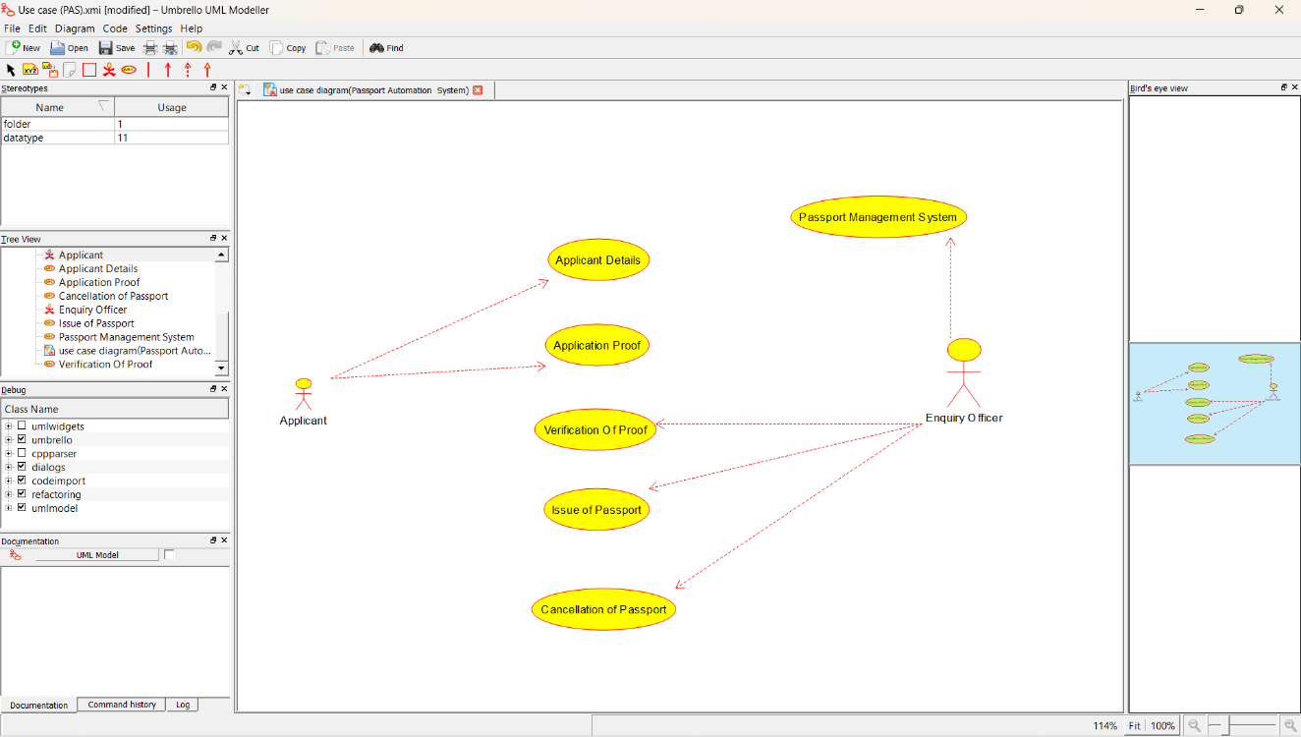



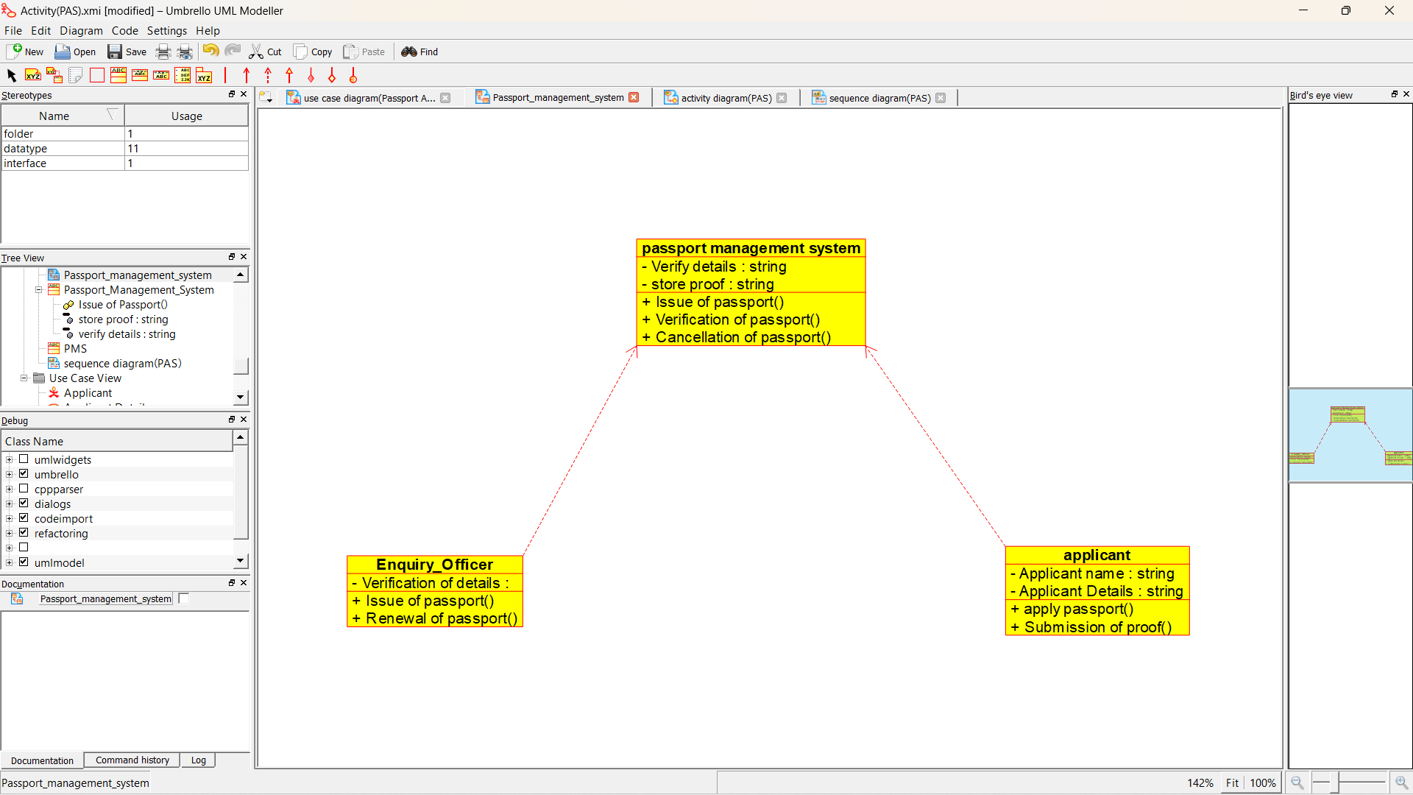

**ACTIVITY DIAGRAM:**

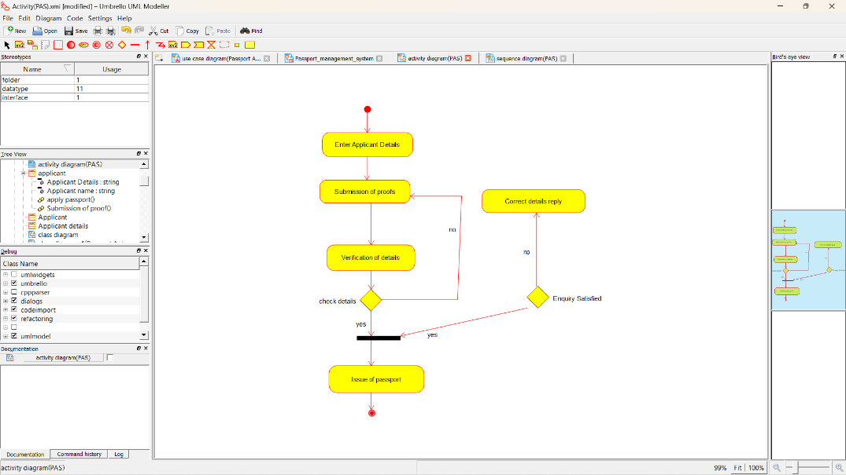

**SEQUENCE DIAGRAM:**

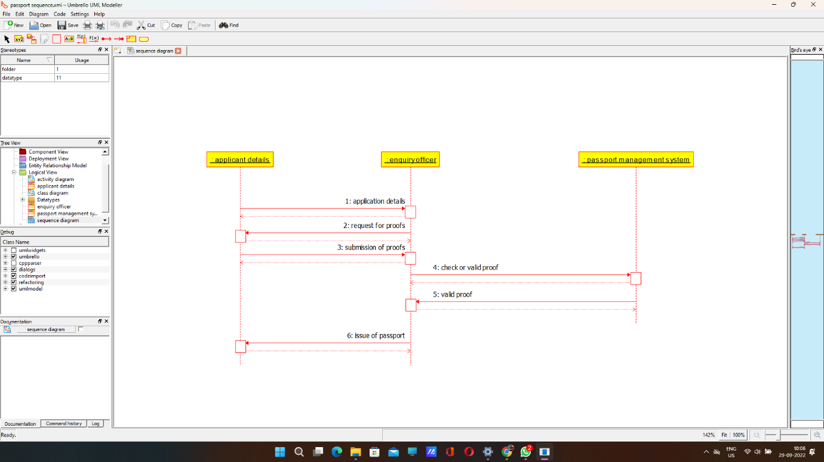

**STATE CHART DIAGRAM :**

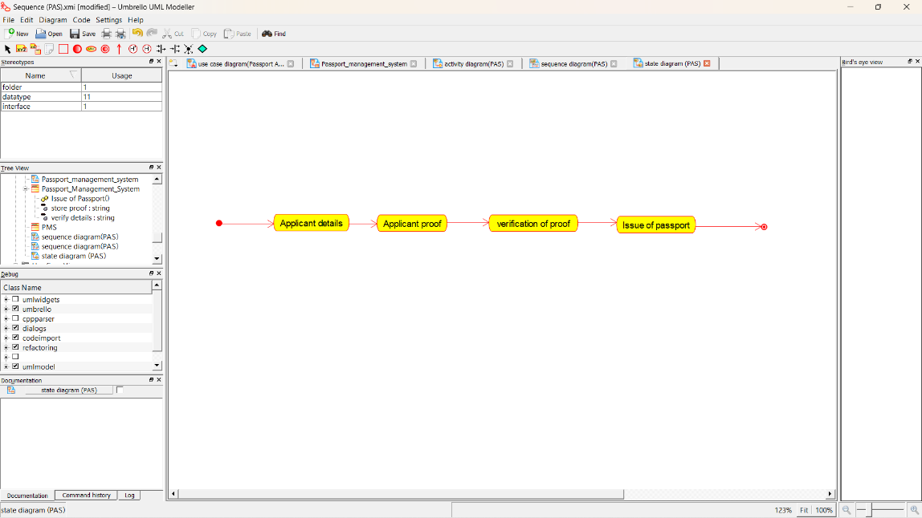

**COLLABORATION DIAGRAM:**

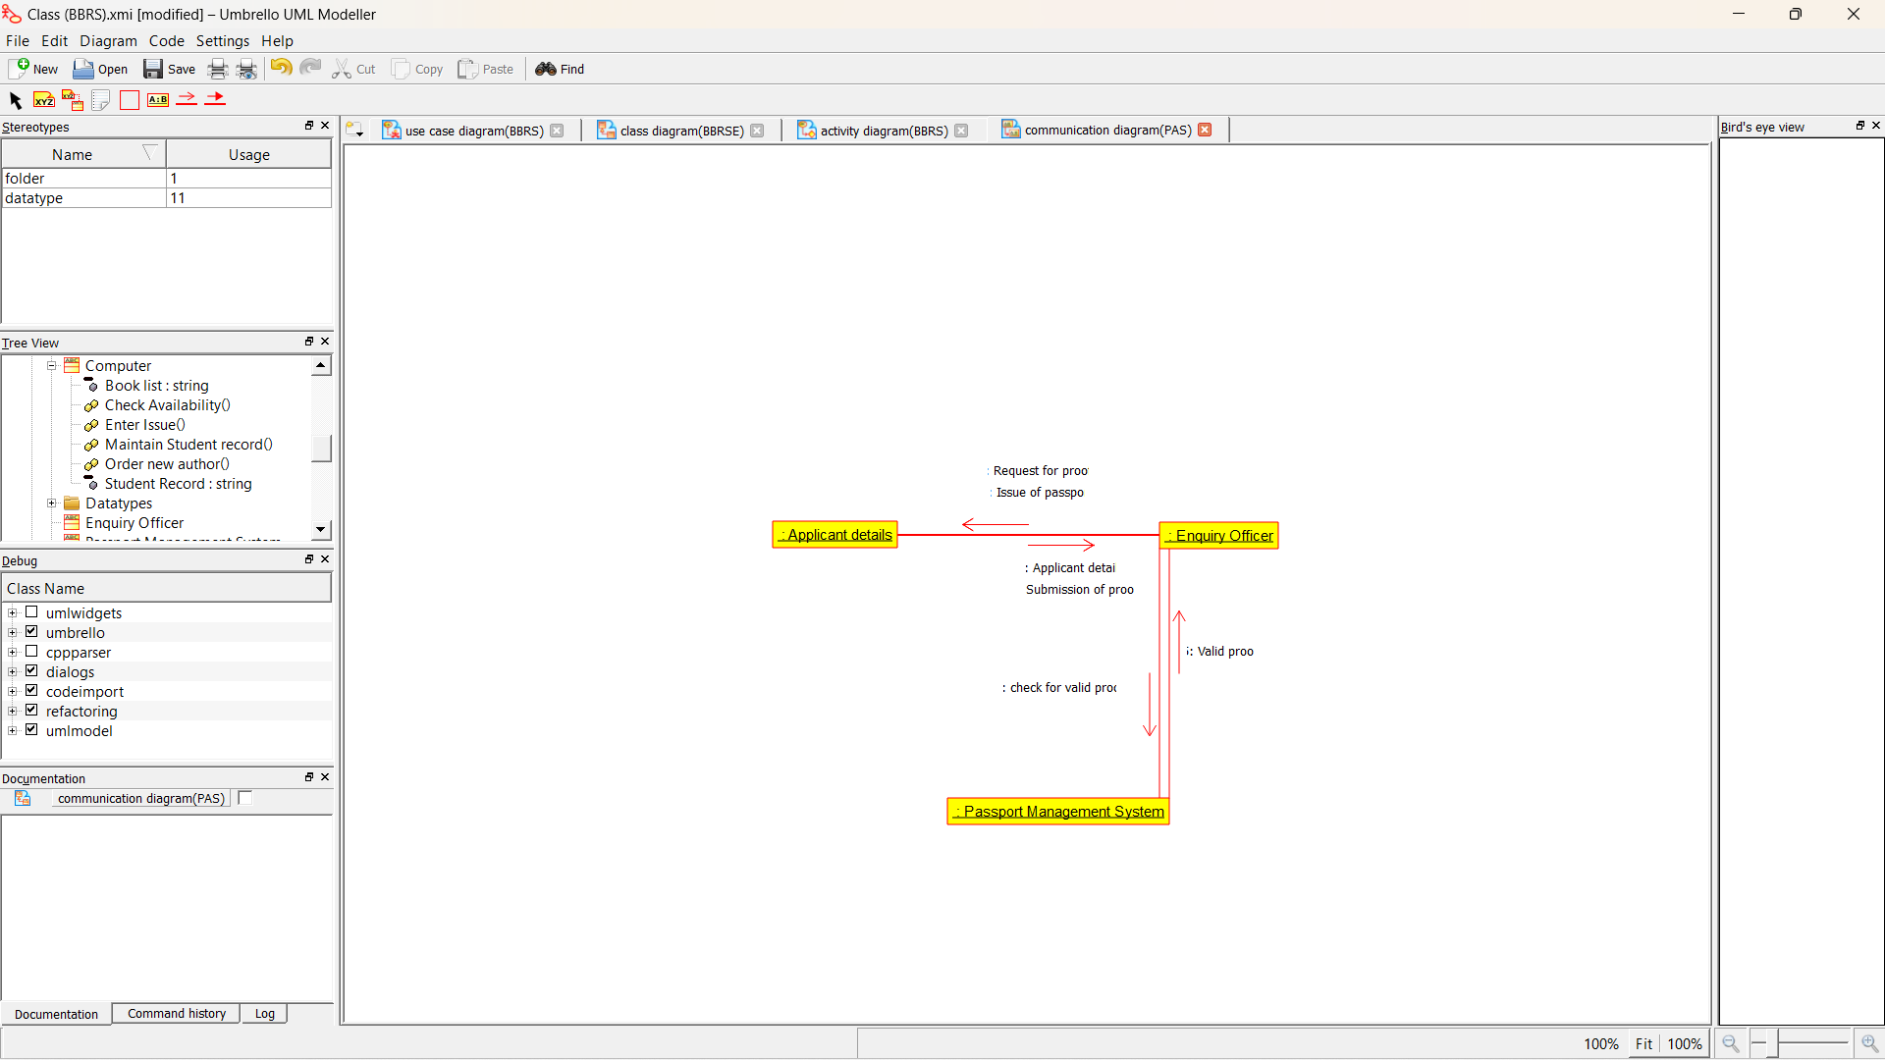

**COMPONENT DIAGRAM :**

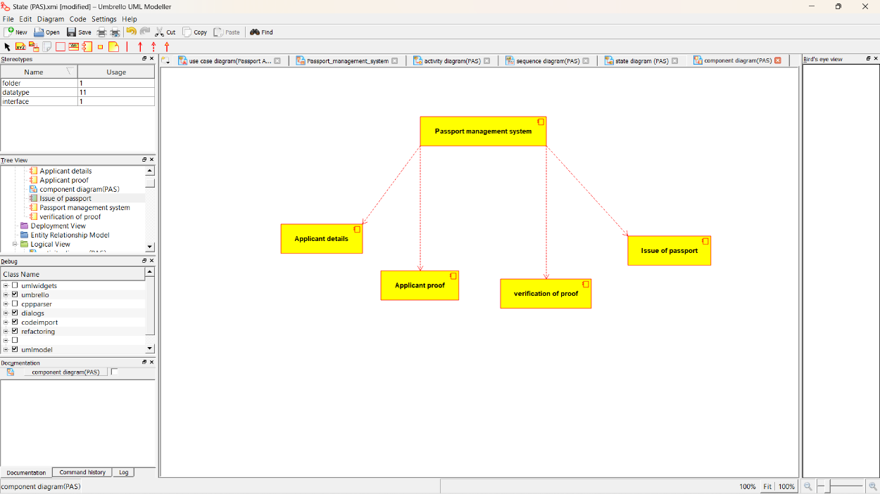

**DEPLOYMENT DIAGRAM :**

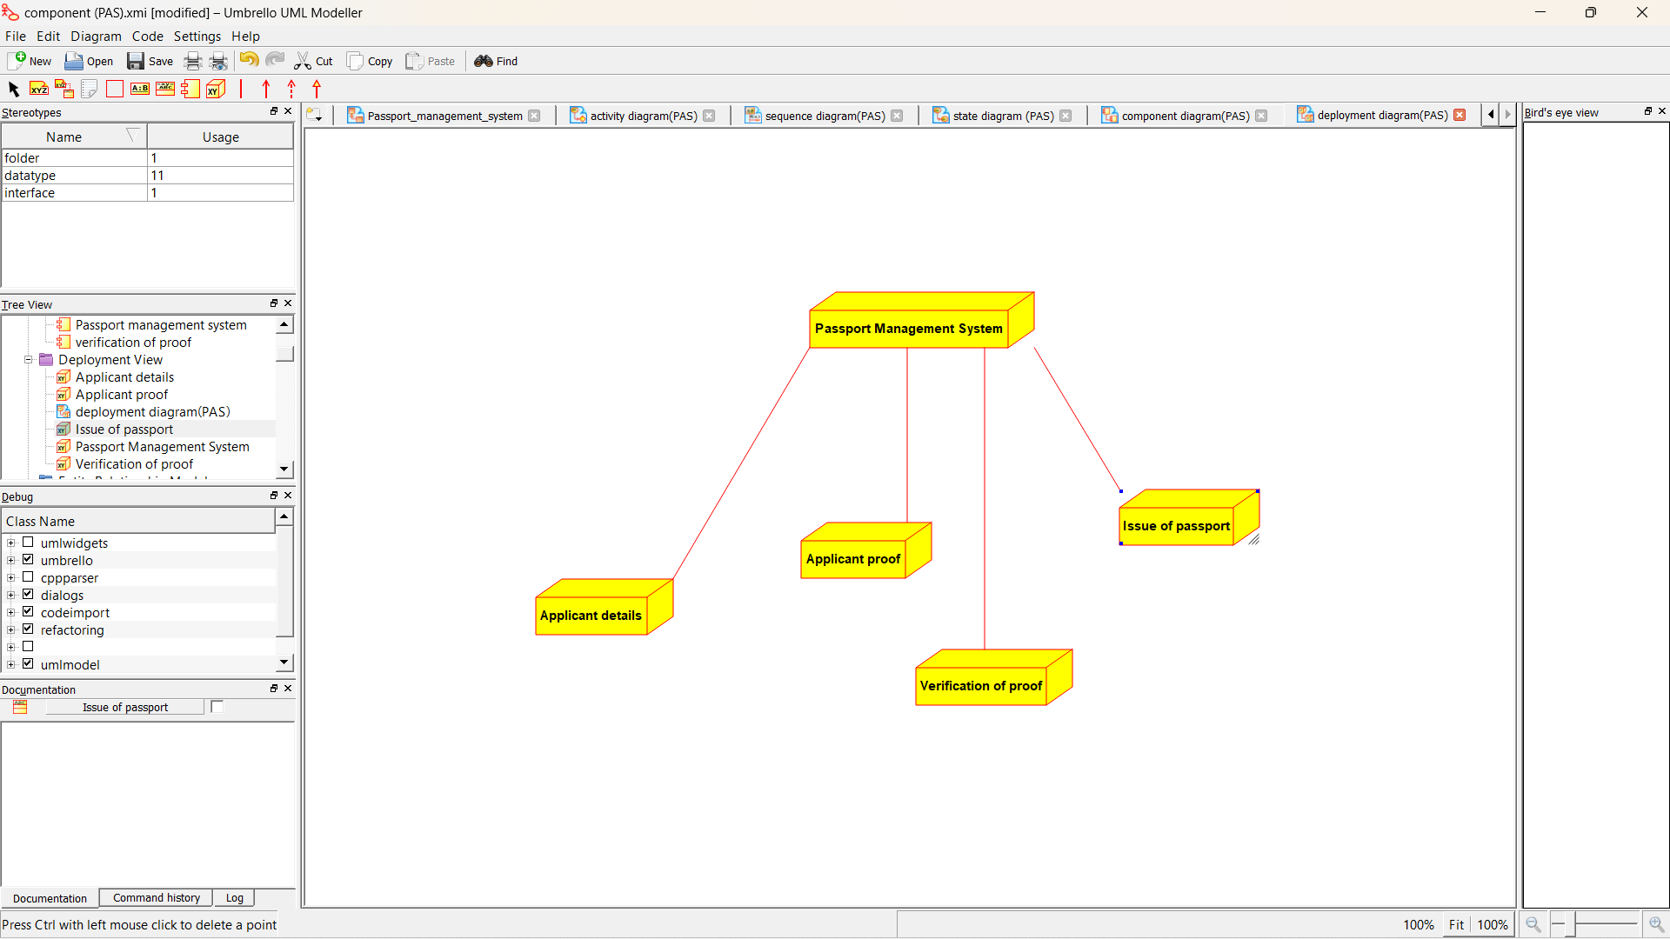

*Program coding:*

*/\*\**

*\* Class APPLICANT*

*\*/*

*public class APPLICANT {*

*//*

*// Fields*

*//*

*private void APPLICANT_NAME;*

*private String applicant_details;*

*//*

*// Constructors*

*//*

*public APPLICANT () { };*

*//*

*// Methods*

*//*

*//*

*// Accessor methods*

*//*

*/\*\**

*\* Set the value of APPLICANT_NAME*

*\* @param newVar the new value of APPLICANT_NAME*

*\*/*

*private void setAPPLICANT_NAME (void newVar) {*

*APPLICANT_NAME = newVar;*

*}*

*/\*\**

*\* Get the value of APPLICANT_NAME*

*\* @return the value of APPLICANT_NAME*

*\*/*

*private void getAPPLICANT_NAME () {*

*return APPLICANT_NAME;*

*}*

*/\*\**

*\* Set the value of applicant_details*

*\* @param newVar the new value of applicant_details*

*\*/*

*private void setApplicant_details (String newVar) {*

*applicant_details = newVar;*

*}*

*/\*\**

*\* Get the value of applicant_details*

*\* @return the value of applicant_details*

*\*/*

*private String getApplicant_details () {*

*return applicant_details;*

*}*

*//*

*// Other methods*

*//*

*/\*\**

*\*/*

*public void apply_passport()*

*{*

*}*

*/\*\**

*\*/*

*public void submission_of_proof()*

*{*

*}*

*}*

*/\*\**

*\* Class ENQUIRY_OFFICER*

*\*/*

*public class ENQUIRY_OFFICER {*

*//*

*// Fields*

*//*

*private String VERIFICATION_OF_DETAILS;*

*//*

*// Constructors*

*//*

*public ENQUIRY_OFFICER () { };*

*//*

*// Methods*

*//*

*//*

*// Accessor methods*

*//*

*/\*\**

*\* Set the value of VERIFICATION_OF_DETAILS*

*\* @param newVar the new value of VERIFICATION_OF_DETAILS*

*\*/*

*private void setVERIFICATION_OF_DETAILS (String newVar) {*

*VERIFICATION_OF_DETAILS = newVar;*

*}*

*/\*\**

*\* Get the value of VERIFICATION_OF_DETAILS*

*\* @return the value of VERIFICATION_OF_DETAILS*

*\*/*

*private String getVERIFICATION_OF_DETAILS () {*

*return VERIFICATION_OF_DETAILS;*

*}*

*//*

*// Other methods*

*//*

*/\*\**

*\*/*

*public void Issue_of_passport()*

*{*

*}*

*/\*\**

*\*/*

*public void renewal_of_passport()*

*{*

*}*

*}*

*/\*\**

*\* Class PASSPORT_MANAGEMENT_SYSTEM*

*\*/*

*public class PASSPORT_MANAGEMENT_SYSTEM {*

*//*

*// Fields*

*//*

*private String VERIFY_DETAILS;*

*private String STORE_PROOF*

*//*

*// Constructors*

*//*

*public PASSPORT_MANAGEMENT_SYSTEM () { };*

*//*

*// Methods*

*//*

*//*

*// Accessor methods*

*//*

*/\*\**

*\* Set the value of VERIFY_DETAILS*

*\* @param newVar the new value of VERIFY_DETAILS*

*\*/*

*private void setVERIFY_DETAILS (String newVar) {*

*VERIFY_DETAILS = newVar;*

*}*

*/\*\**

*\* Get the value of VERIFY_DETAILS*

*\* @return the value of VERIFY_DETAILS*

*\*/*

*private String getVERIFY_DETAILS () {*

*return VERIFY_DETAILS;*

*}*

*/\*\**

*\* Set the value of STORE_PROOF*

*\* @param newVar the new value of STORE_PROOF*

*\*/*

*private void setSTORE_PROOF (String newVar) {*

*STORE_PROOF = newVar;*

*}*

*/\*\**

*\* Get the value of STORE_PROOF*

*\* @return the value of STORE_PROOF*

*\*/*

*private String getSTORE_PROOF () {*

*return STORE_PROOF;*

*}*

*//*

*// Other methods*

*//*

*/\*\**

*\*/*

*public void Issue_of_passport()*

*{*

*}*

*/\*\**

*\*/*

*public void verification_of_passport()*

*{*

*}*

*/\*\**

*\*/*

*public void cancellation_of_passpott()*

*{*

*}*

*}*

**2.BOOK BANK SYSTEM**

**USE CASE DIAGRAM:**

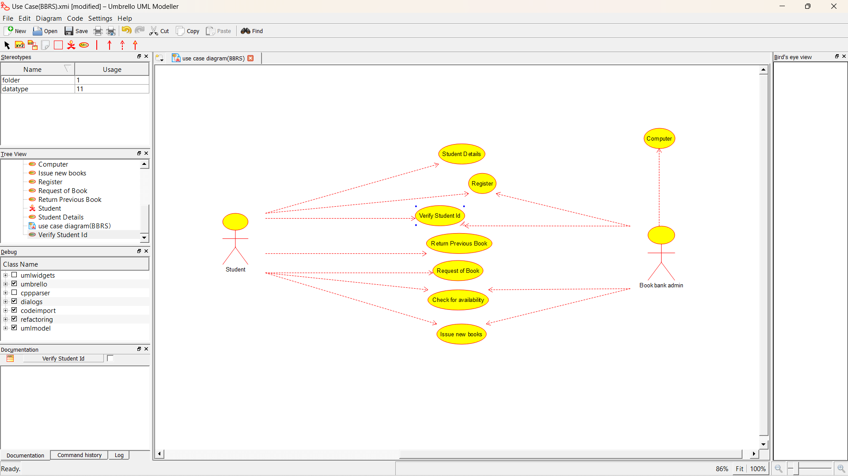

**CLASS DIAGRAM:**

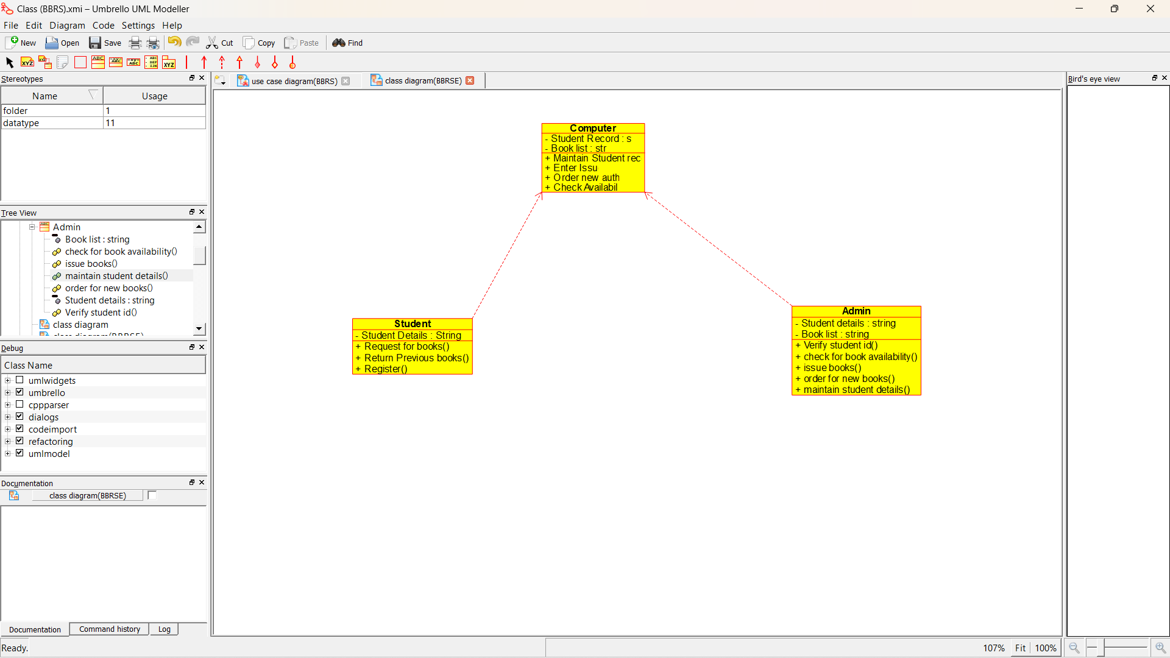

**ACTIVITY DIAGRAM:**

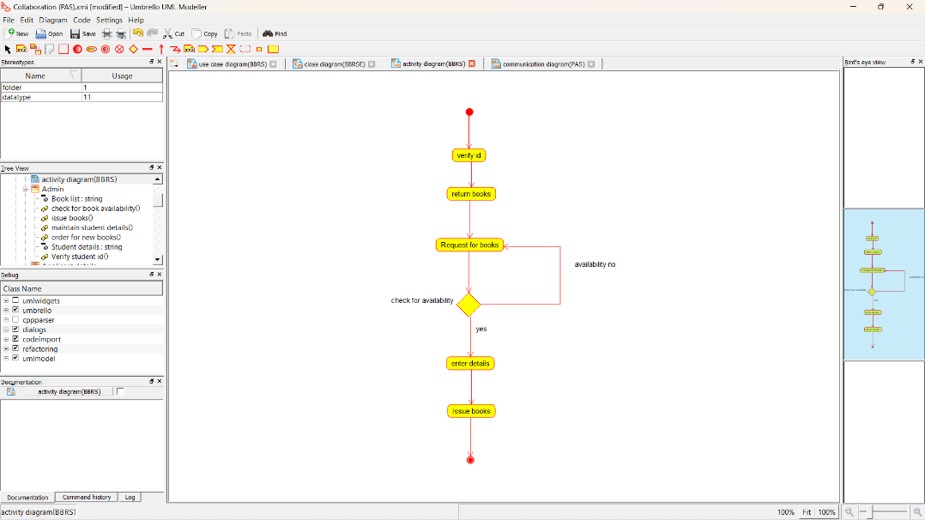

**SEQUENCE DIAGRAM:**

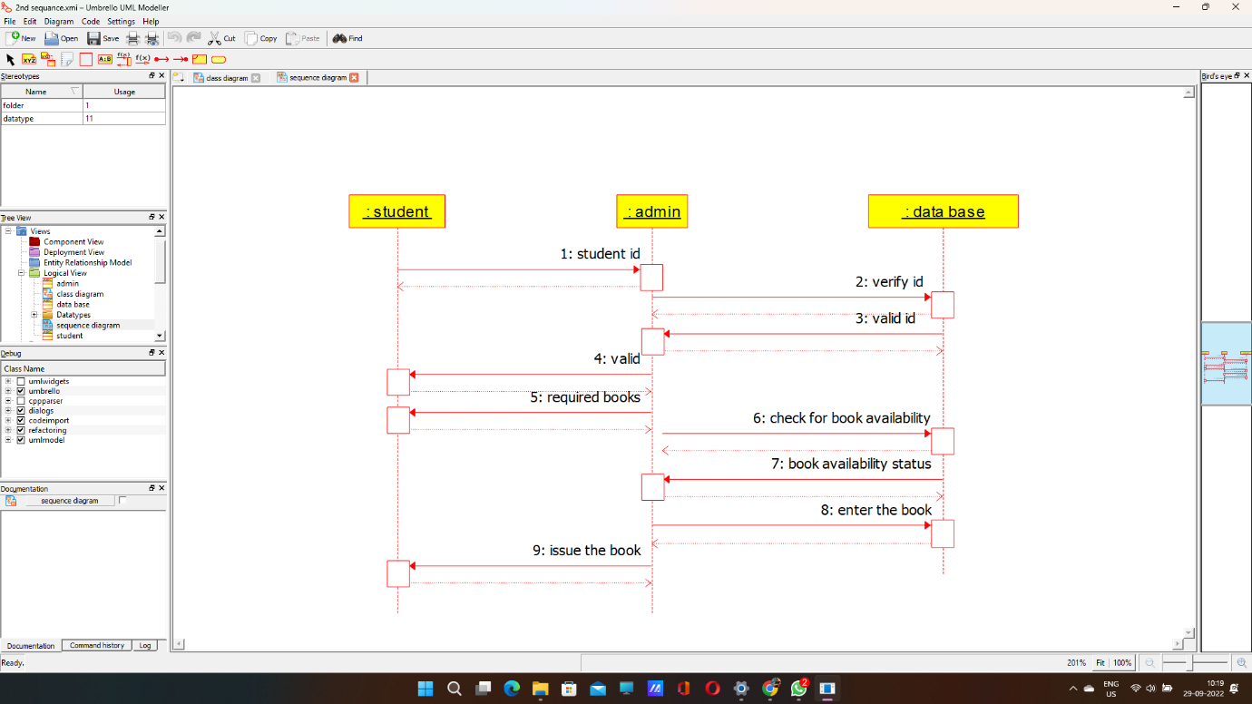

**COLLABORATION DIAGRAM:**

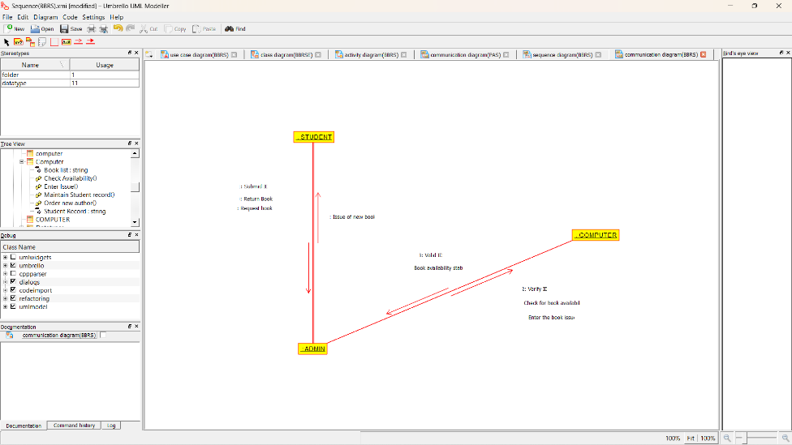

**STATE CHART DIAGRAM**

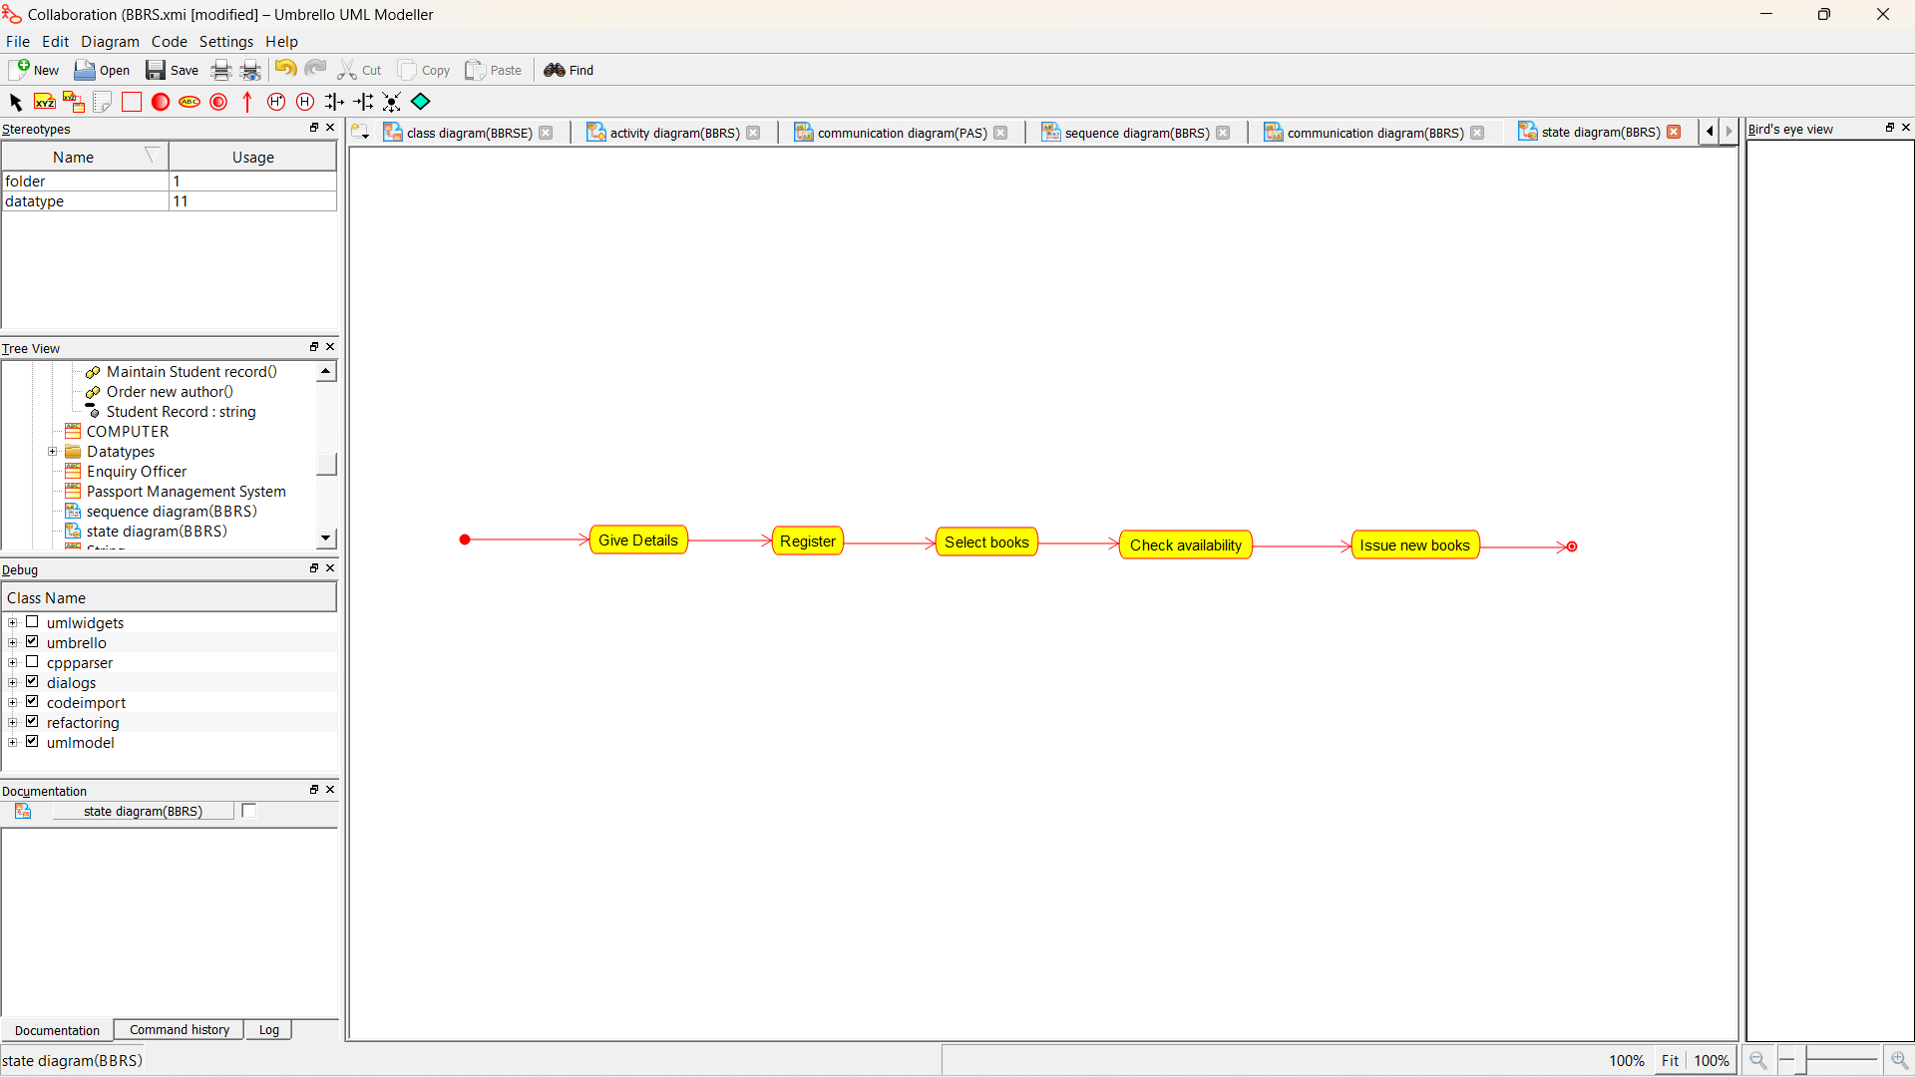

**COMPONENT DIAGRAM**

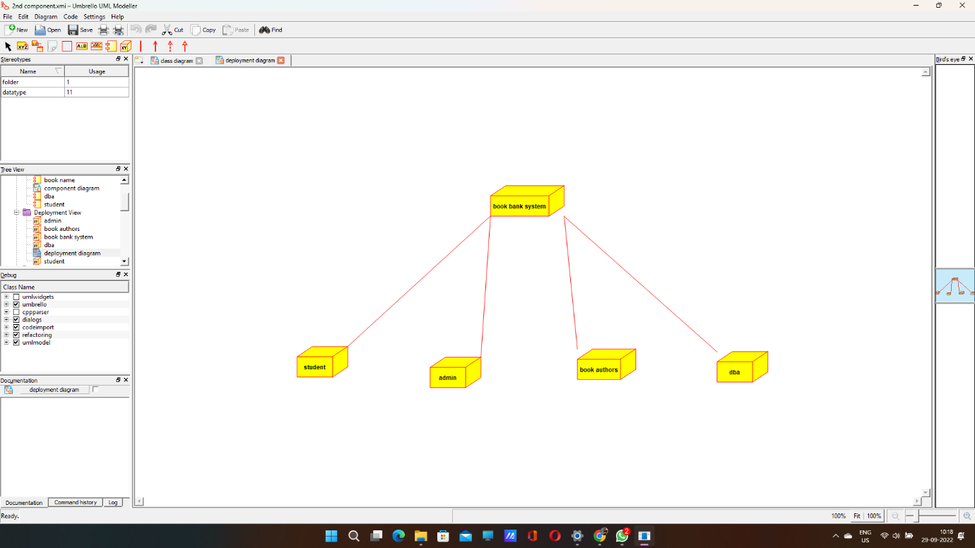

**DEPLOYMENT DIAGRAM**

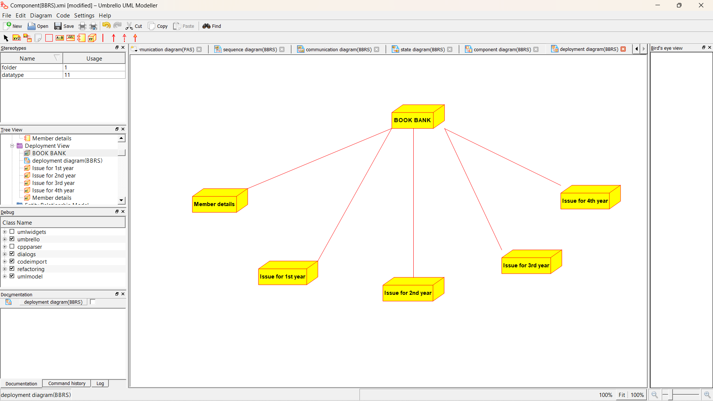

*Program coding:*

**ADMIN:**

Public class admin

{

Public integer student details;

Public integer book list;

Public void verify stud id()

{

}

Public void check for availability()

{

}

Public void issue books()

{

}

Public void order for new author()

{

}

Public void maintains stud details()

{

}

}

**STUDENT:**

Public class stud

{

Public integer studdetails;

**3.EXAM REGISTRATION\**

**USE CASE DIAGRAM:**

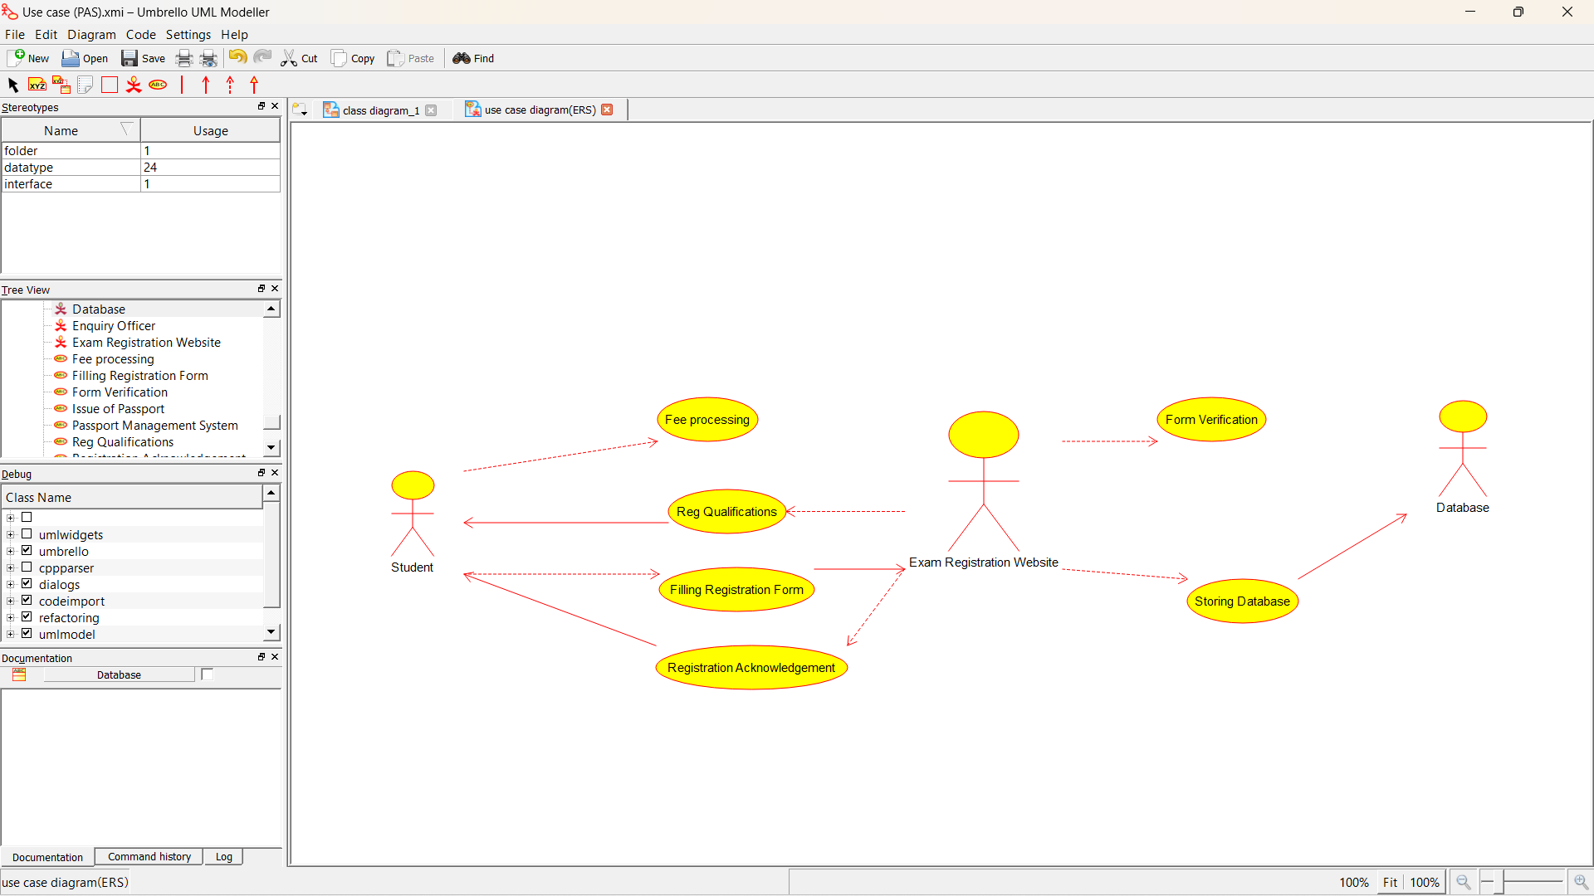

CLASS DIAGRAM: 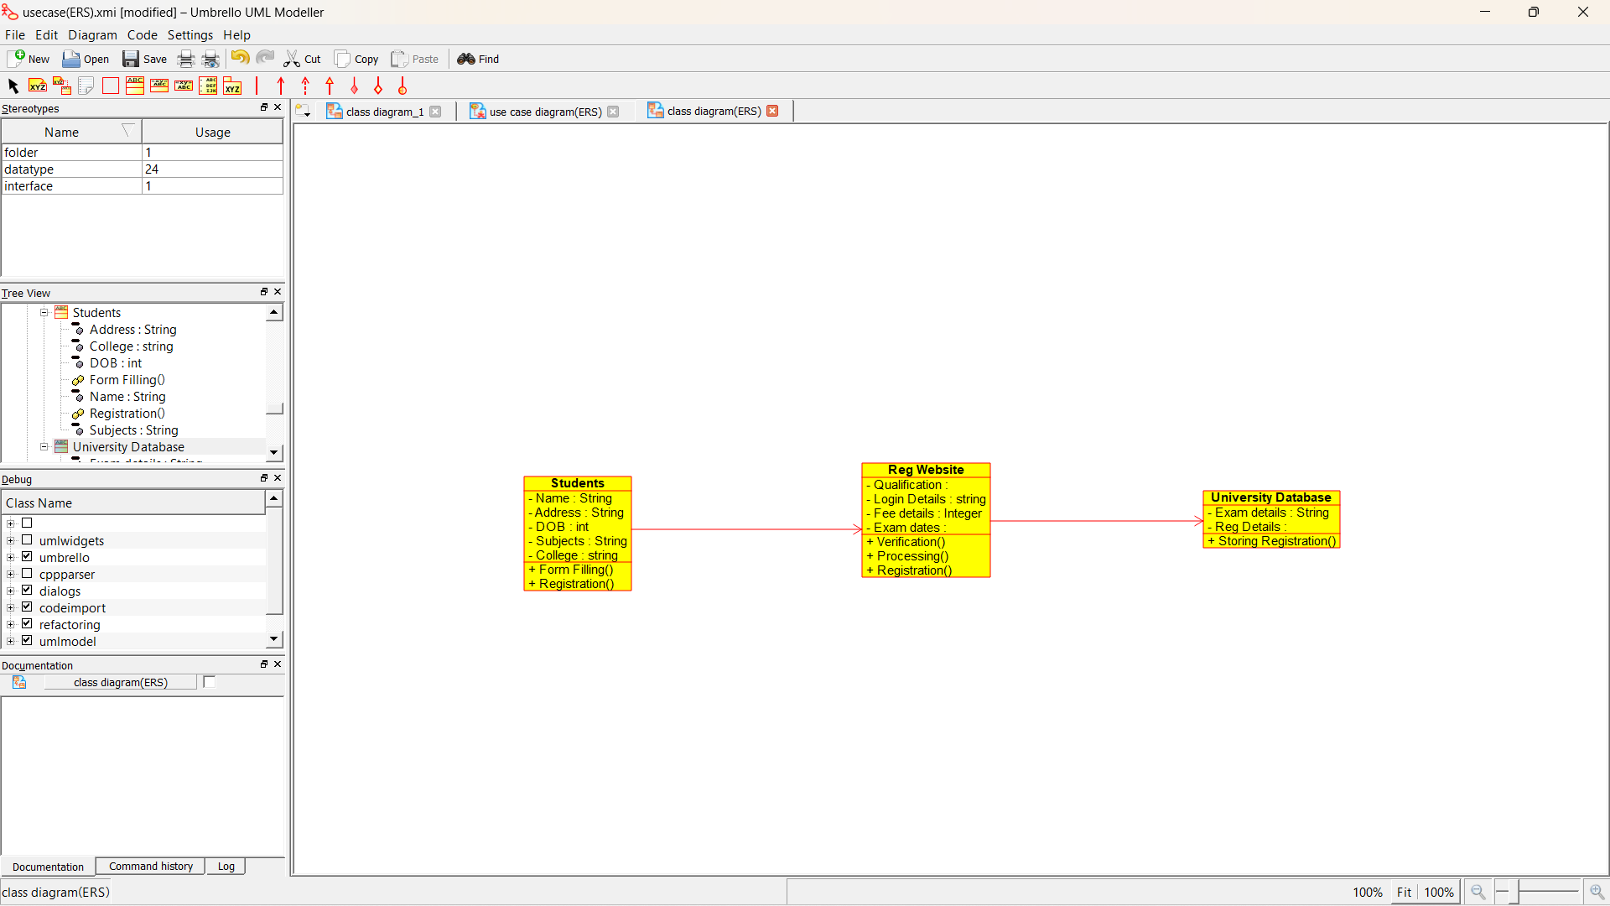

ACTIVITY DIAGRAM:

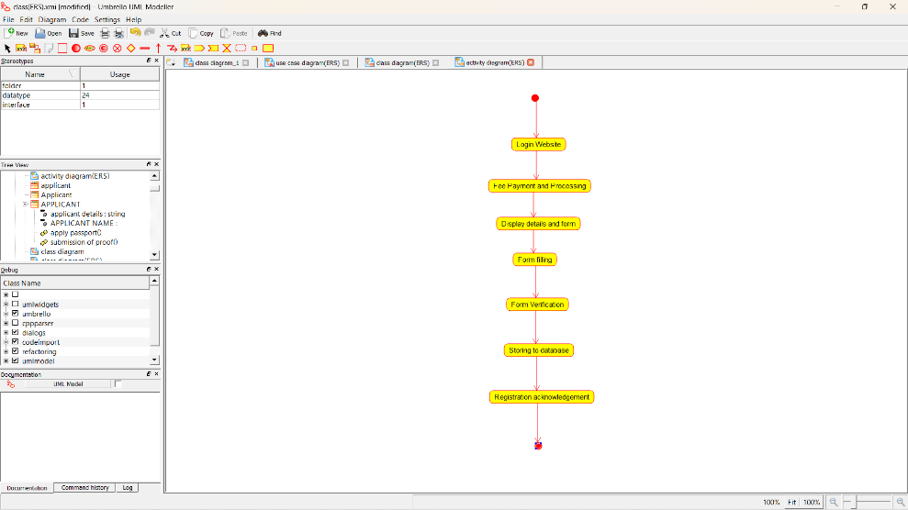

SEQUENCE DIAGRAM:

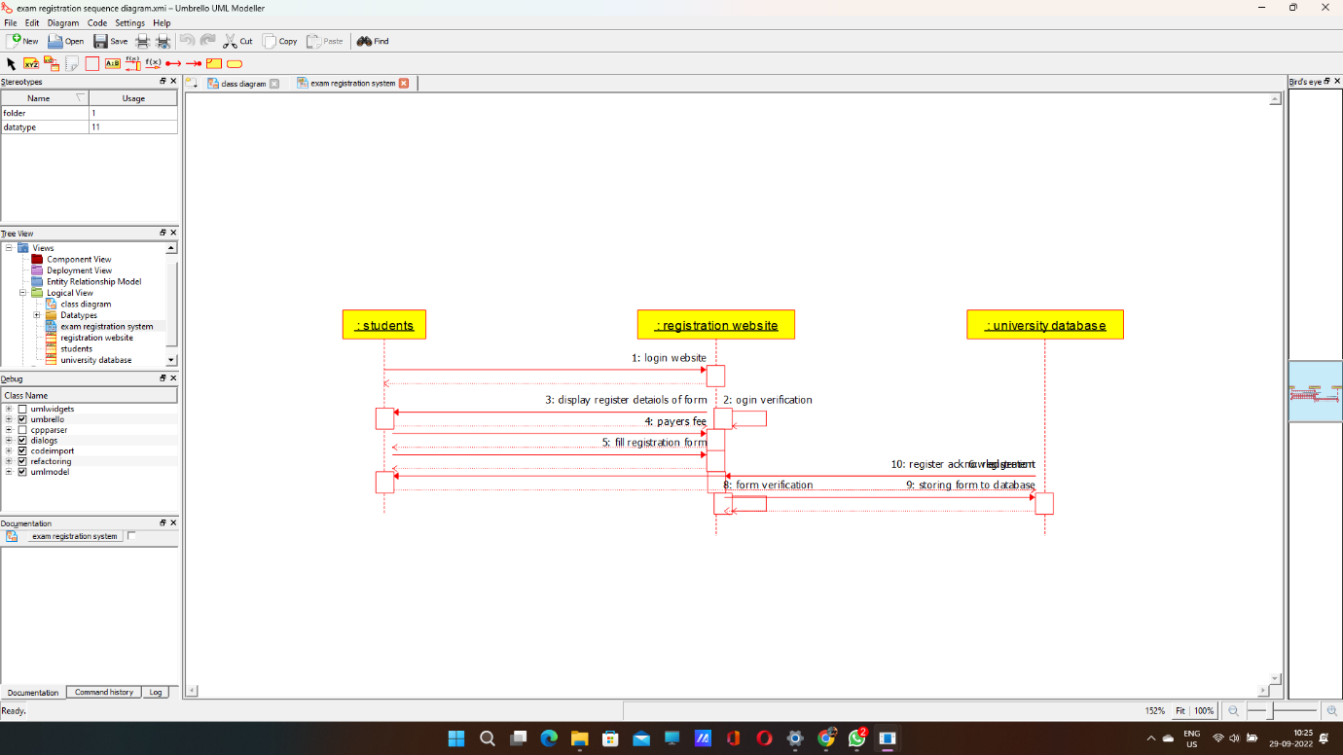

COLLABORATION DIAGRAM:

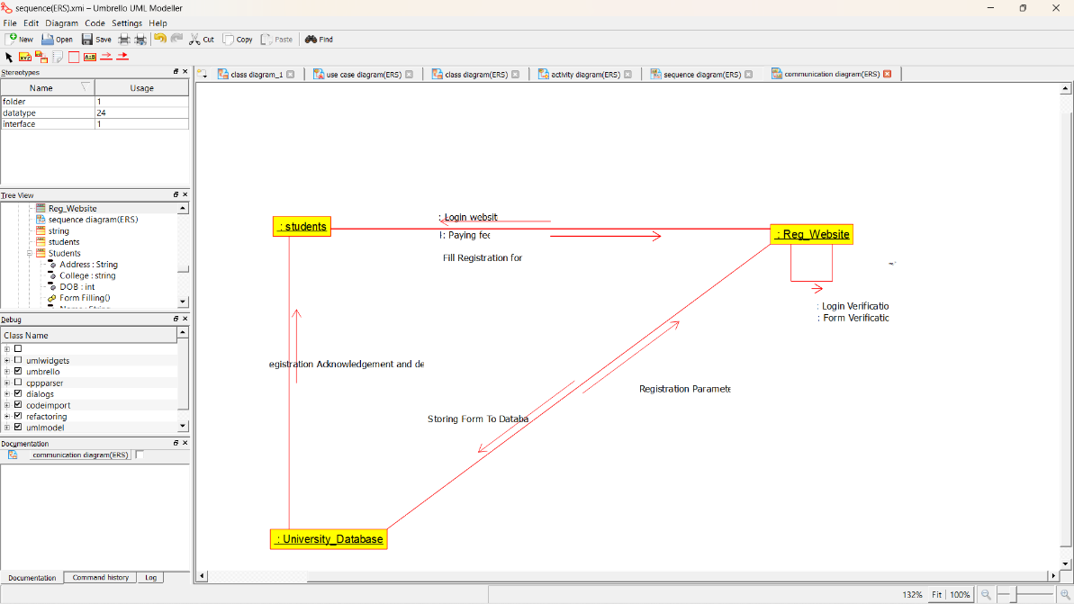

STATE DIAGRAM:

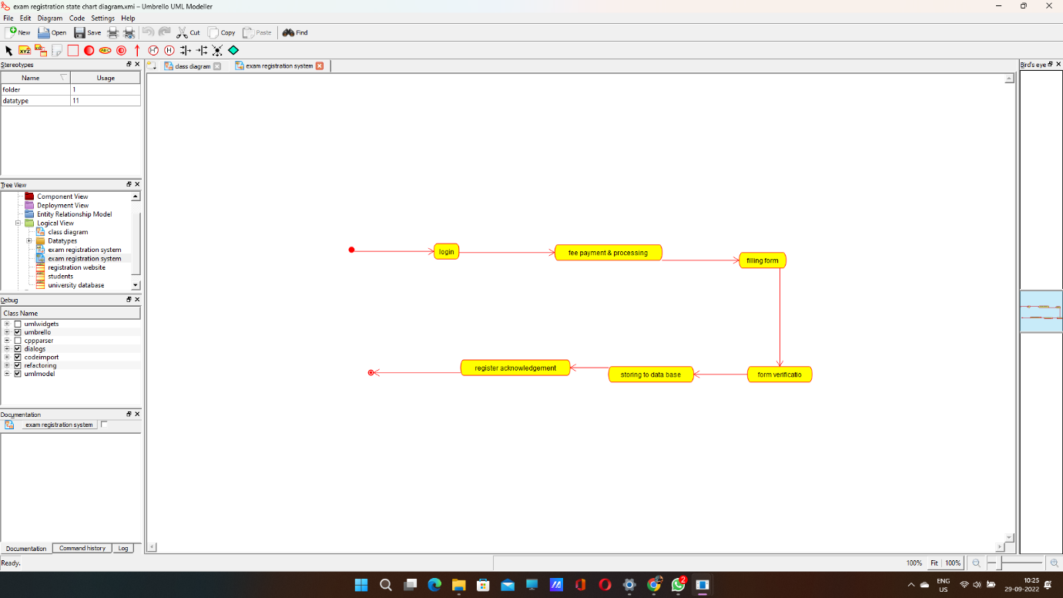

COMPONENT DIAGRAM:

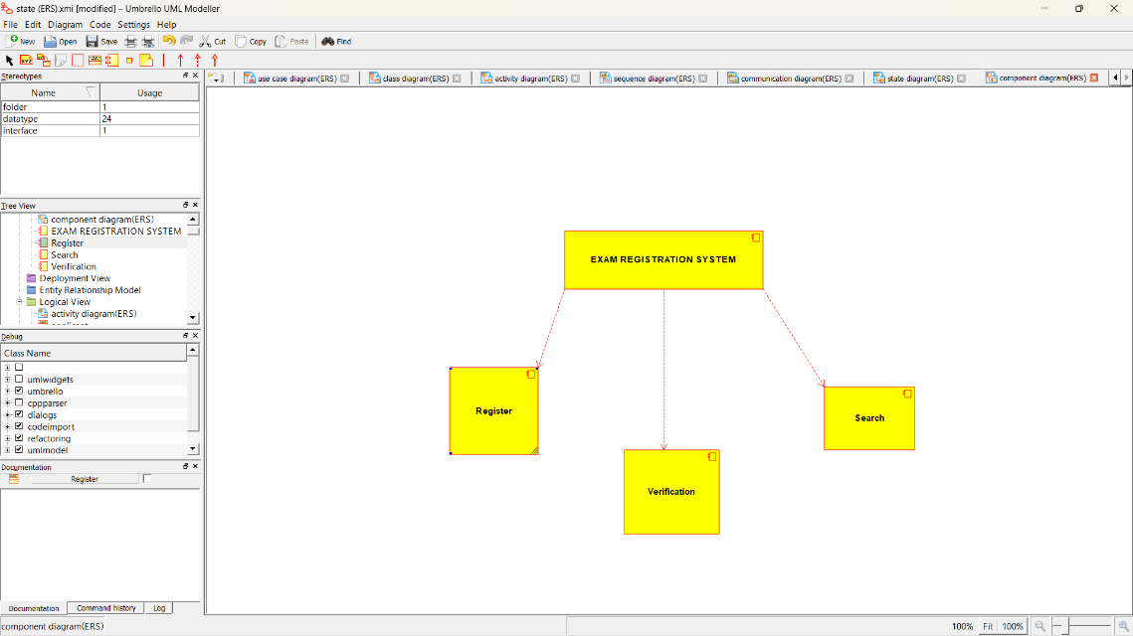

DEPLOYMENT DIAGRAM: 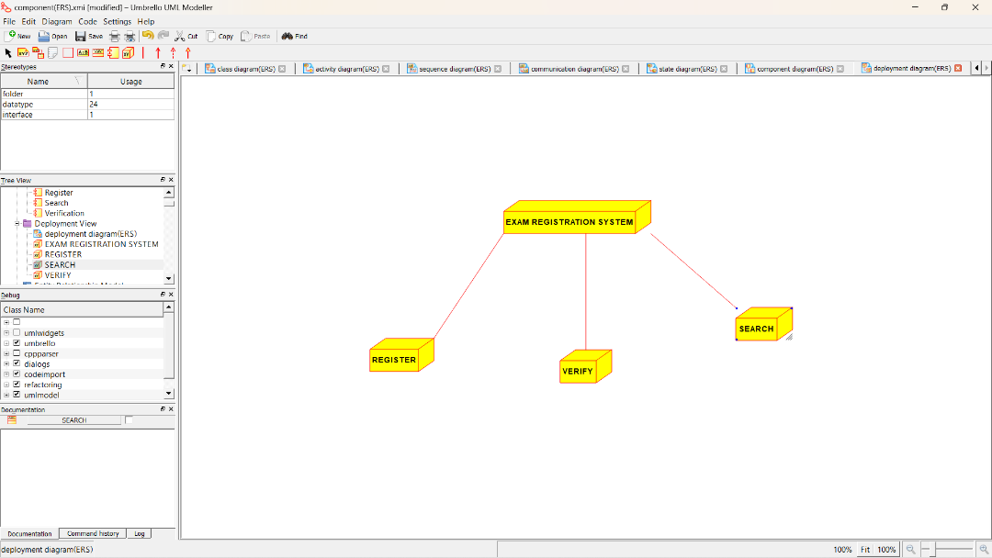

*PROGRAM CODING:*

/**

* Class Students

*/

public class Students {

//

// Fields

//

private String Name;

private String Address;

private int DOB;

private String Subjects;

private String College;

//

// Constructors

//

public Students () { };

//

// Methods

//

//

// Accessor methods

//

/**

* Set the value of Name

* @param newVar the new value of Name

*/

private void setName (String newVar) {

Name = newVar;

}

/**

* Get the value of Name

* @return the value of Name

*/

private String getName () {

return Name;

}

/**

* Set the value of Address

* @param newVar the new value of Address

*/

private void setAddress (String newVar) {

Address = newVar;

}

/**

* Get the value of Address

* @return the value of Address

*/

private String getAddress () {

return Address;

}

/**

* Set the value of DOB

* @param newVar the new value of DOB

*/

private void setDOB (int newVar) {

DOB = newVar;

}

/**

* Get the value of DOB

* @return the value of DOB

*/

private int getDOB () {

return DOB;

}

/**

* Set the value of Subjects

* @param newVar the new value of Subjects

*/

private void setSubjects (String newVar) {

Subjects = newVar;

}

/**

* Get the value of Subjects

* @return the value of Subjects

*/

private String getSubjects () {

return Subjects;

}

/**

* Set the value of College

* @param newVar the new value of College

*/

private void setCollege (String newVar) {

College = newVar;

}

/**

* Get the value of College

* @return the value of College

*/

private String getCollege () {

return College;

}

//

// Other methods

//

/**

*/

public void Form_Filling()

{

}

/**

*/

public void Registration()

{

}

}

/**

* Class Reg_Website

*/

public class Reg_Website {

//

// Fields

//

private void Qualification;

private String Login_Details;

private Integer Fee_details;

private void Exam_dates;

//

// Constructors

//

public Reg_Website () { };

//

// Methods

//

//

// Accessor methods

//

/**

* Set the value of Qualification

* @param newVar the new value of Qualification

*/

private void setQualification (void newVar) {

Qualification = newVar;

}

/**

* Get the value of Qualification

* @return the value of Qualification

*/

private void getQualification () {

return Qualification;

}

/**

* Set the value of Login_Details

* @param newVar the new value of Login_Details

*/

private void setLogin_Details (String newVar) {

Login_Details = newVar;

}

/**

* Get the value of Login_Details

* @return the value of Login_Details

*/

private String getLogin_Details () {

return Login_Details;

}

/**

* Set the value of Fee_details

* @param newVar the new value of Fee_details

*/

private void setFee_details (Integer newVar) {

Fee_details = newVar;

}

/**

* Get the value of Fee_details

* @return the value of Fee_details

*/

private Integer getFee_details () {

return Fee_details;

}

/**

* Set the value of Exam_dates

* @param newVar the new value of Exam_dates

*/

private void setExam_dates (void newVar) {

Exam_dates = newVar;

}

/**

* Get the value of Exam_dates

* @return the value of Exam_dates

*/

private void getExam_dates () {

return Exam_dates;

}

//

// Other methods

//

/**

*/

public void Verification()

{

}

/**

*/

public void Processing()

{

}

/**

*/

public void Registration()

{

}

}

/**

* Class University_Database

*/

public class University_Database {

//

// Fields

//

private String Exam_details;

private void Reg_Details;

//

// Constructors

//

public University_Database () { };

//

// Methods

//

**4.STOCK MAINTAINANCE SYSTEM**

USECASE DIAGRAM:

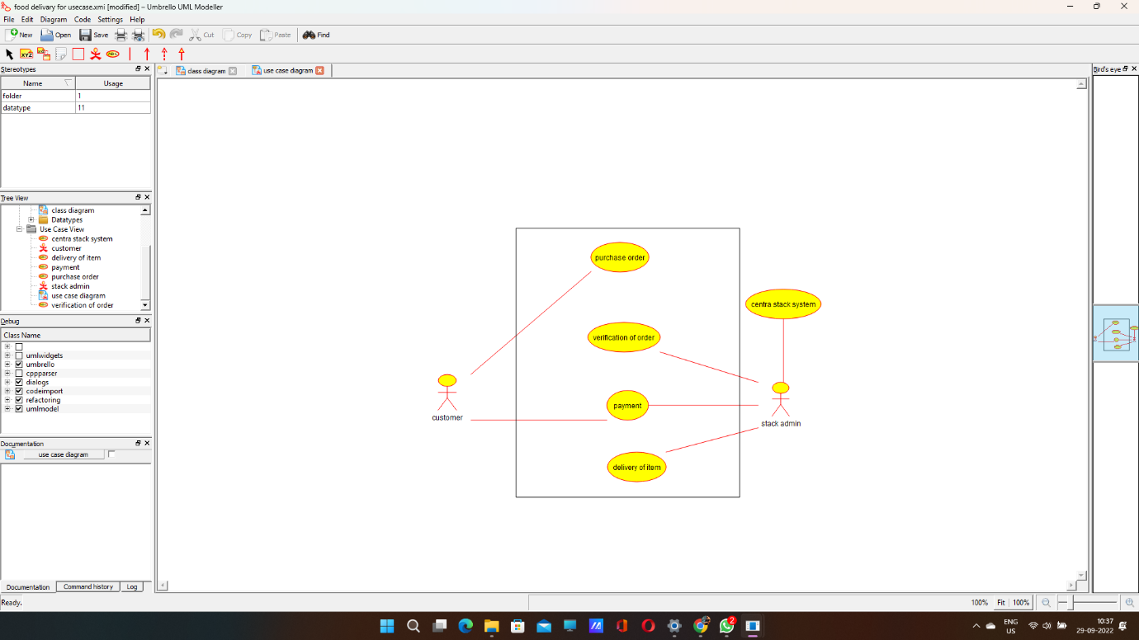

CLASS DIAGRAM:

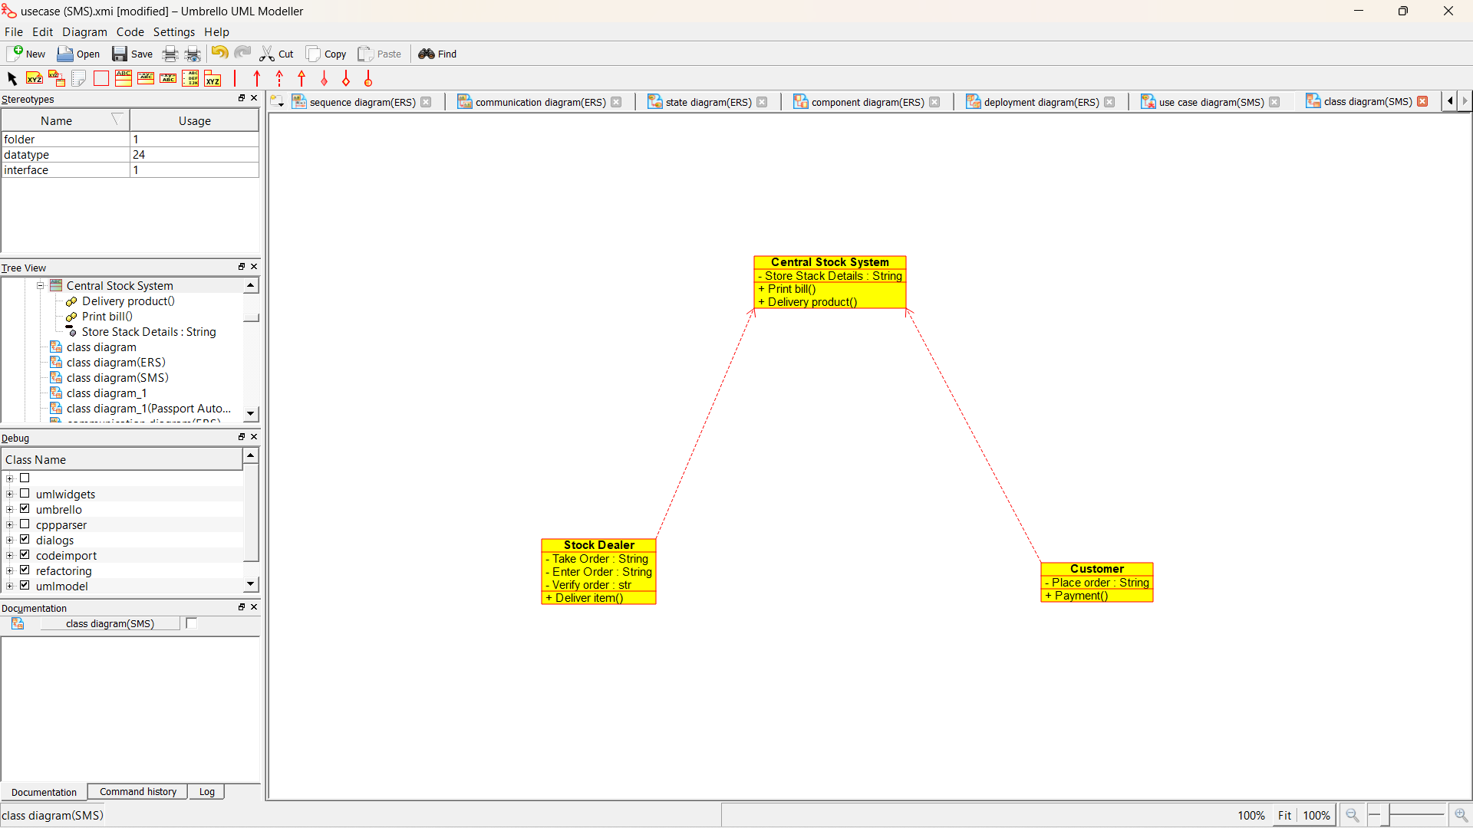

ACTIVITY DIAGRAM:

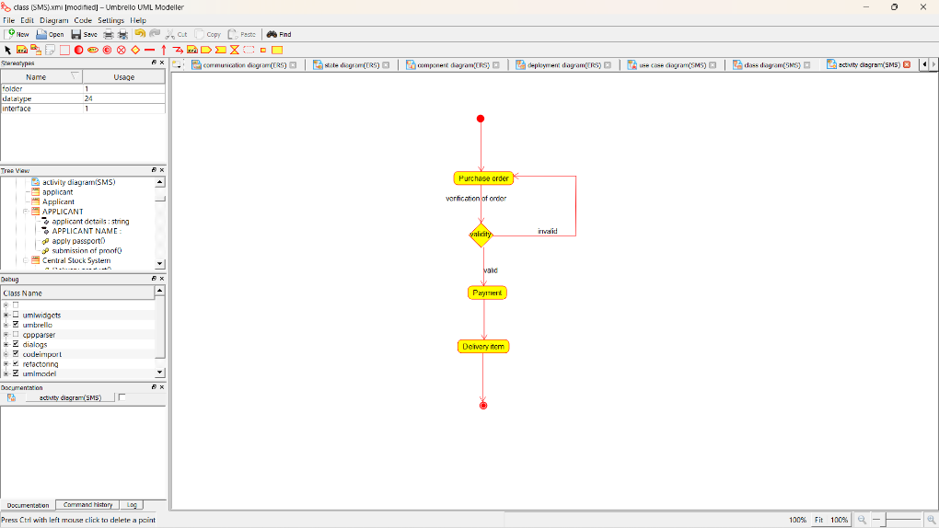

SEQUENCE DIAGRAM:

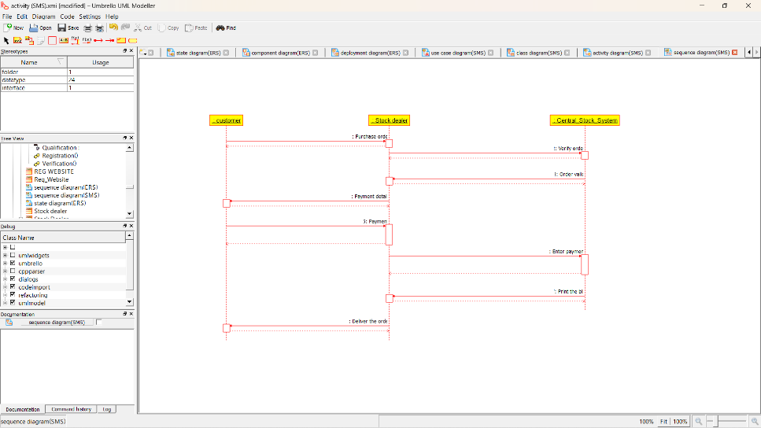

COLLABORATION DIAGRAM:

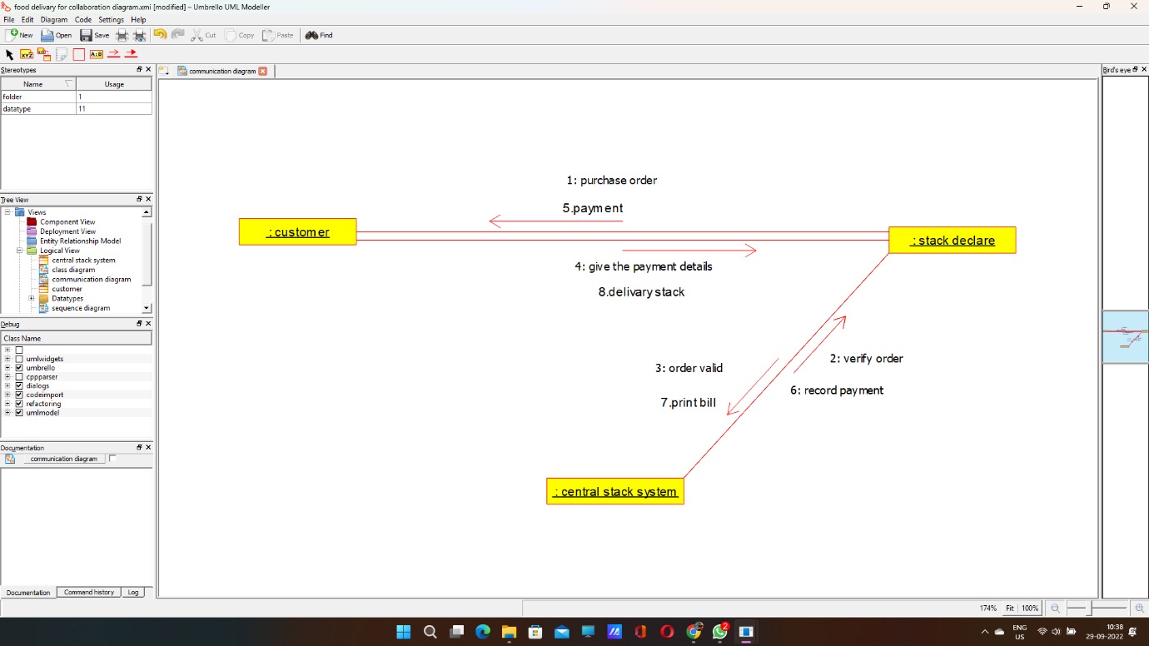

STATE DIAGRAM:

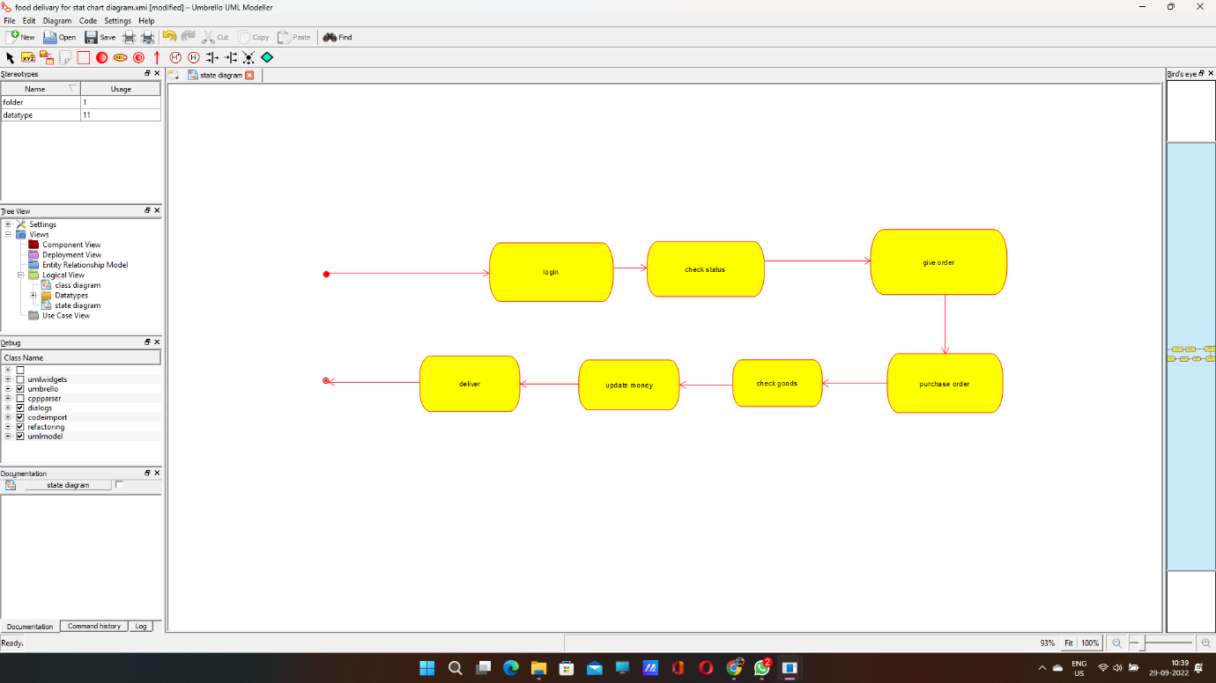

COMPONENT DIAGRAM:

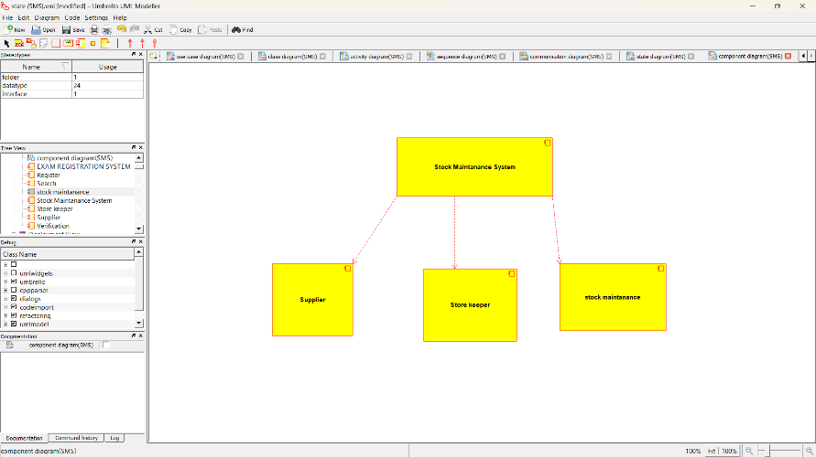

DEPLOYMENT DIAGRAM:

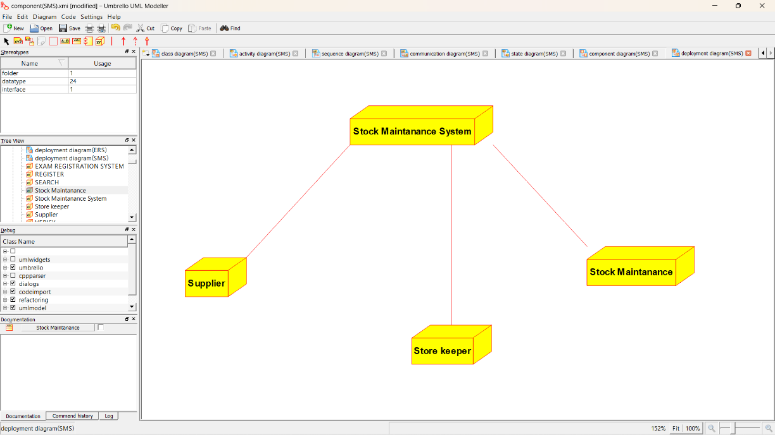

*PROGRAM CODING:*

/**

* Class Central_Stock_System

*/

public class Central_Stock_System {

//

// Fields

//

private String Store_Stack_Details;

//

// Constructors

//

public Central_Stock_System () { };

//

// Methods

//

//

// Accessor methods

//

/**

* Set the value of Store_Stack_Details

* @param newVar the new value of Store_Stack_Details

*/

private void setStore_Stack_Details (String newVar) {

Store_Stack_Details = newVar;

}

/**

* Get the value of Store_Stack_Details

* @return the value of Store_Stack_Details

*/

private String getStore_Stack_Details () {

return Store_Stack_Details;

}

//

// Other methods

//

/**

*/

public void Print_bill()

{

}

/**

*/

public void Delivery_product()

{

}

}

/**

* Class Stock_Dealer

*/

public class Stock_Dealer {

//

// Fields

//

private String Take_Order;

private String Enter_Order;

private str Verify_order;

//

// Constructors

//

public Stock_Dealer () { };

//

// Methods

//

//

// Accessor methods

//

/**

* Set the value of Take_Order

* @param newVar the new value of Take_Order

*/

private void setTake_Order (String newVar) {

Take_Order = newVar;

}

/**

* Get the value of Take_Order

* @return the value of Take_Order

*/

private String getTake_Order () {

return Take_Order;

}

/**

* Set the value of Enter_Order

* @param newVar the new value of Enter_Order

*/

private void setEnter_Order (String newVar) {

Enter_Order = newVar;

}

/**

* Get the value of Enter_Order

* @return the value of Enter_Order

*/

private String getEnter_Order () {

return Enter_Order;

}

/**

**5.ONLINE COURSE REGISTRATION**

USECASE DIAGRAM:

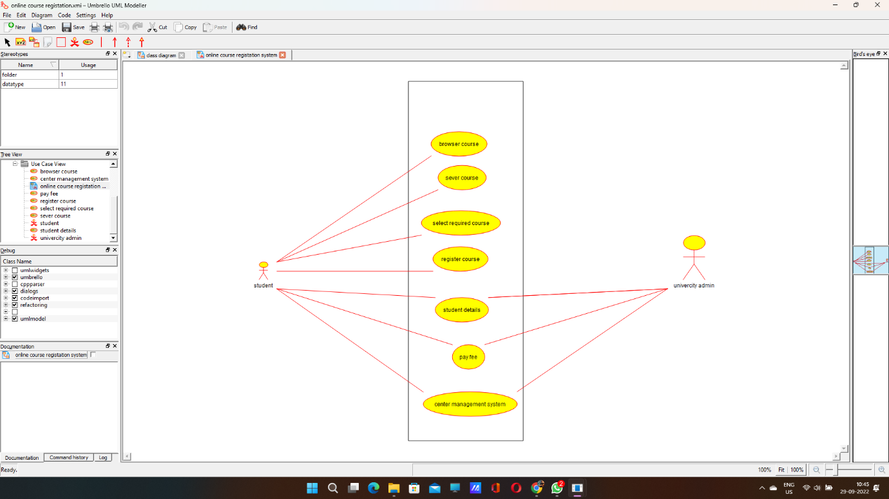

CLASS DIAGRAM:

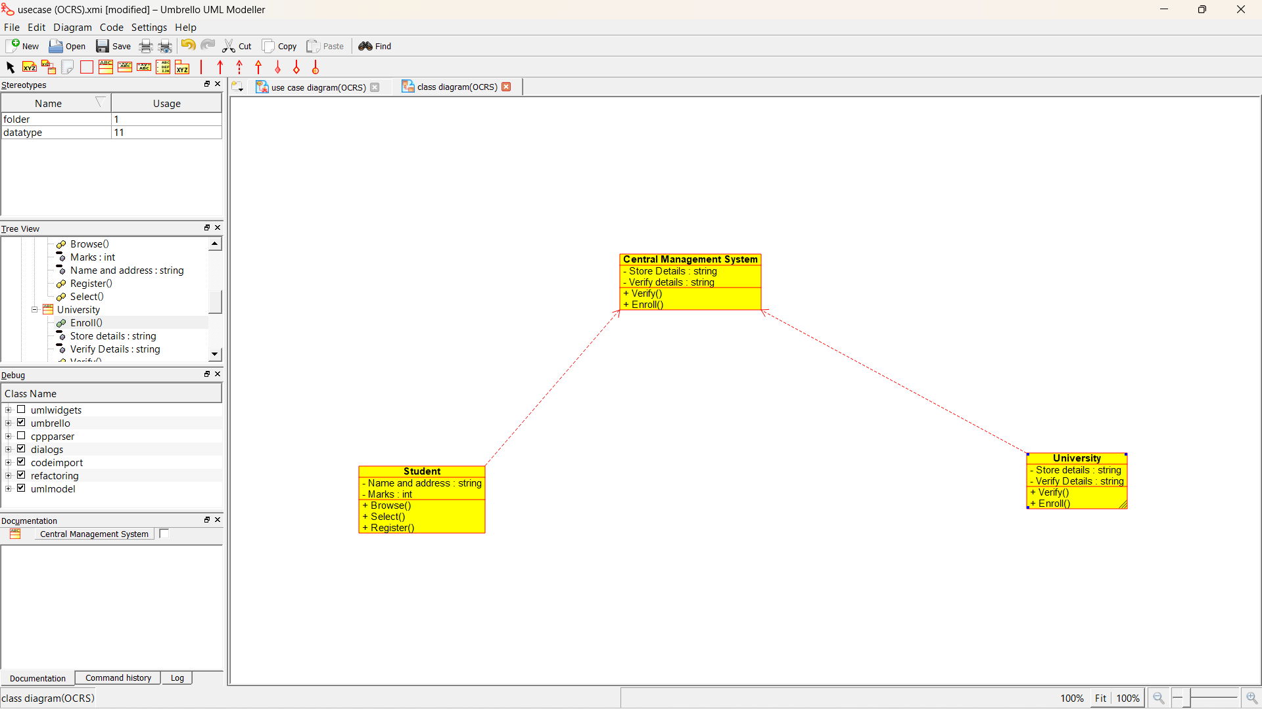

ACTIVITY DIAGRAM:

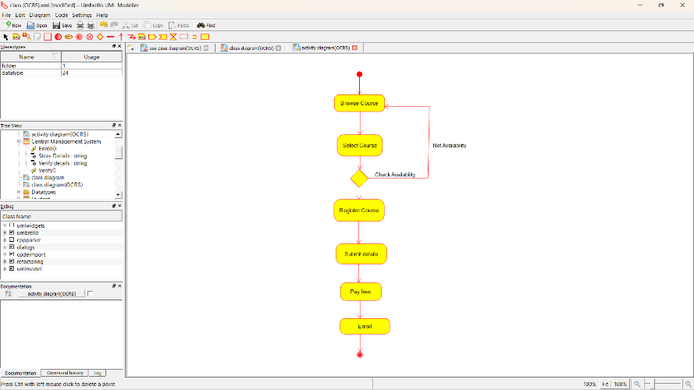

SEQUENCE DIAGRAM:

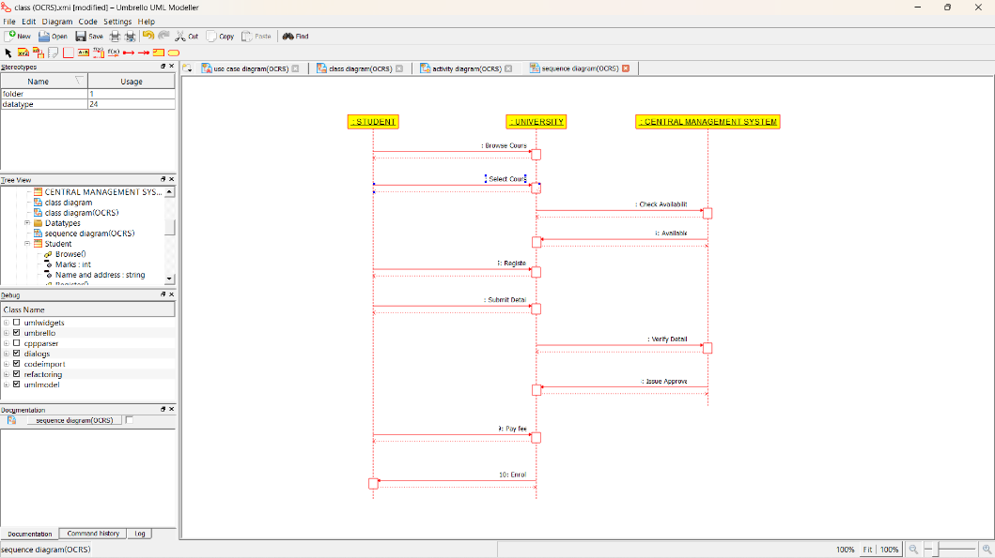

COLLABORATION DIAGRAM:

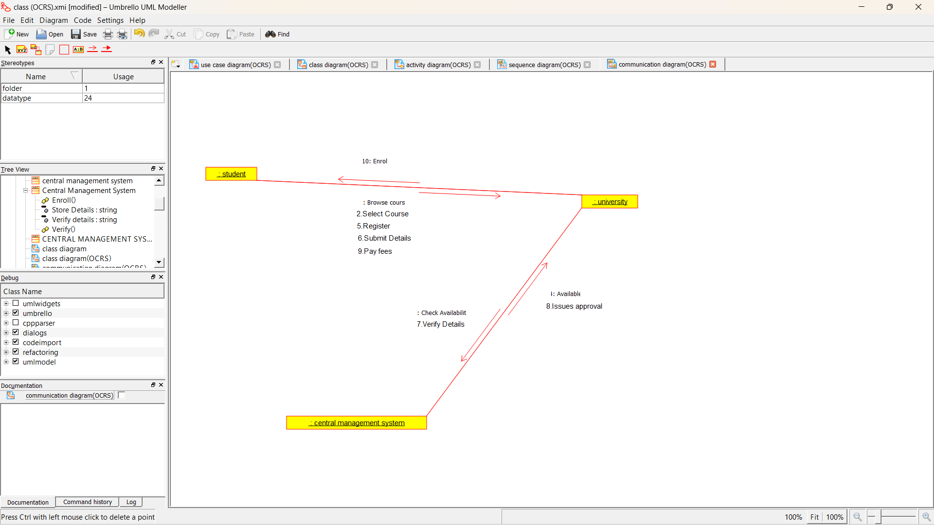

STATE DIAGRAM:

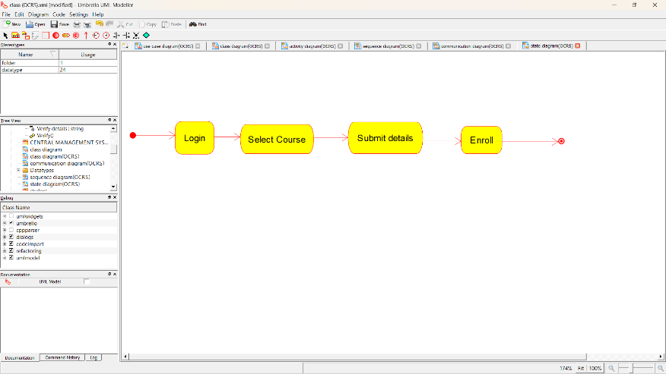

COMPONENT DIAGRAM:

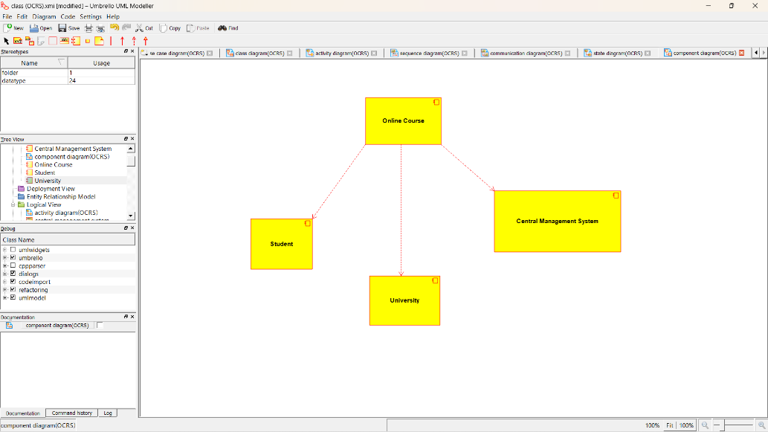

DEPLOYMENT DIAGRAM:

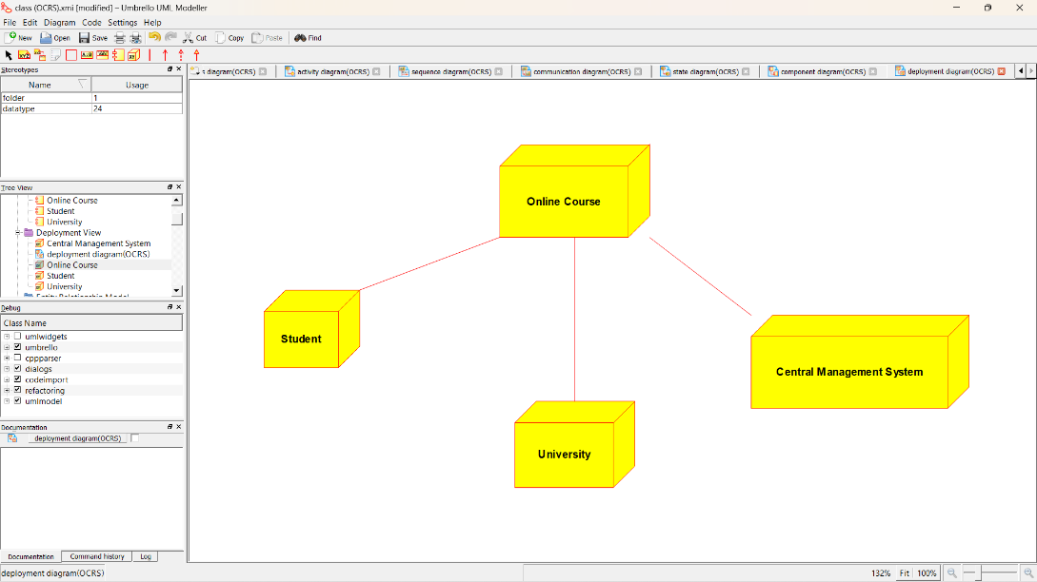

*PROGRAM CODING:*

/**

* Class Central_Management_System

*/

public class Central_Management_System {

//

// Fields

//

private String Store_Details;

private String Verify_details;

//

// Constructors

//

public Central_Management_System () { };

//

// Methods

//

//

// Accessor methods

//

/**

* Set the value of Store_Details

* @param newVar the new value of Store_Details

*/

private void setStore_Details (String newVar) {

Store_Details = newVar;

}

/**

* Get the value of Store_Details

* @return the value of Store_Details

*/

private String getStore_Details () {

return Store_Details;

}

/**

* Set the value of Verify_details

* @param newVar the new value of Verify_details

*/

private void setVerify_details (String newVar) {

Verify_details = newVar;

}

/**

* Get the value of Verify_details

* @return the value of Verify_details

*/

private String getVerify_details () {

return Verify_details;

}

//

// Other methods

//

/**

*/

public void Verify()

{

}

/**

*/

public void Enroll()

{

}

}

/**

* Class Student

*/

public class Student {

//

// Fields

//

private String Name_and_address;

private int Marks;

//

// Constructors

//

public Student () { };

//

// Methods

//

//

// Accessor methods

//

/**

* Set the value of Name_and_address

* @param newVar the new value of Name_and_address

*/

private void setName_and_address (String newVar) {

Name_and_address = newVar;

}

/**

* Get the value of Name_and_address

* @return the value of Name_and_address

*/

private String getName_and_address () {

return Name_and_address;

}

/**

* Set the value of Marks

* @param newVar the new value of Marks

*/

private void setMarks (int newVar) {

Marks = newVar;

}

/**

* Get the value of Marks

* @return the value of Marks

*/

private int getMarks () {

return Marks;

}

//

// Other methods

//

/**

*/

public void Browse()

{

}

/**

*/

public void Select()

{

}

/**

*/

public void Register()

{

}

}

/**

* Class University

*/

public class University {

//

// Fields

//

private String Store_details;

private String Verify_Details;

//

// Constructors

//

public University () { };

//

// Methods

//

//

// Accessor methods

//

/**

* Set the value of Store_details

* @param newVar the new value of Store_details

*/

private void setStore_details (String newVar) {

Store_details = newVar;

}

/**

* Get the value of Store_details

* @return the value of Store_details

*/

private String getStore_details () {

return Store_details;

}

/**

* Set the value of Verify_Details

* @param newVar the new value of Verify_Details

*/

private void setVerify_Details (String newVar) {

Verify_Details = newVar;

}

/**

* Get the value of Verify_Details

* @return the value of Verify_Details

*/

private String getVerify_Details () {

return Verify_Details;

}

//

// Other methods

//

/**

*/

public void Verify()

{

}

/**

*/

public void Enroll()

{

}

}

**6.E-TICKETING**

**USE CASE DIAGRAM**:

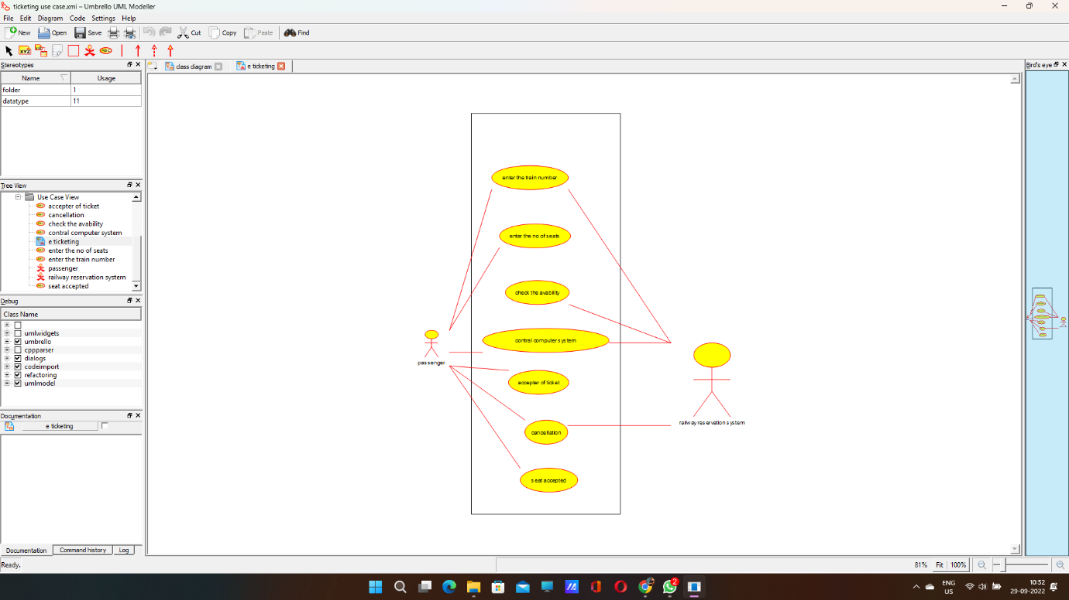

**CLASS DIAGRAM:**

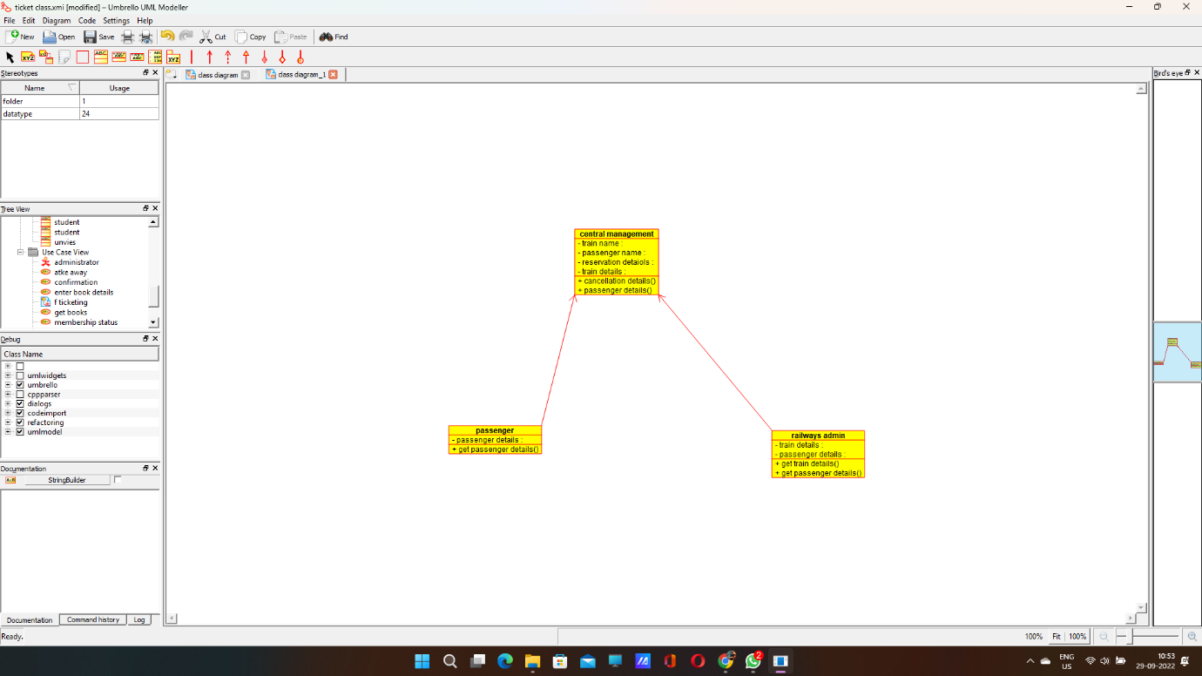

**ACTIVITY DIAGRAM:**

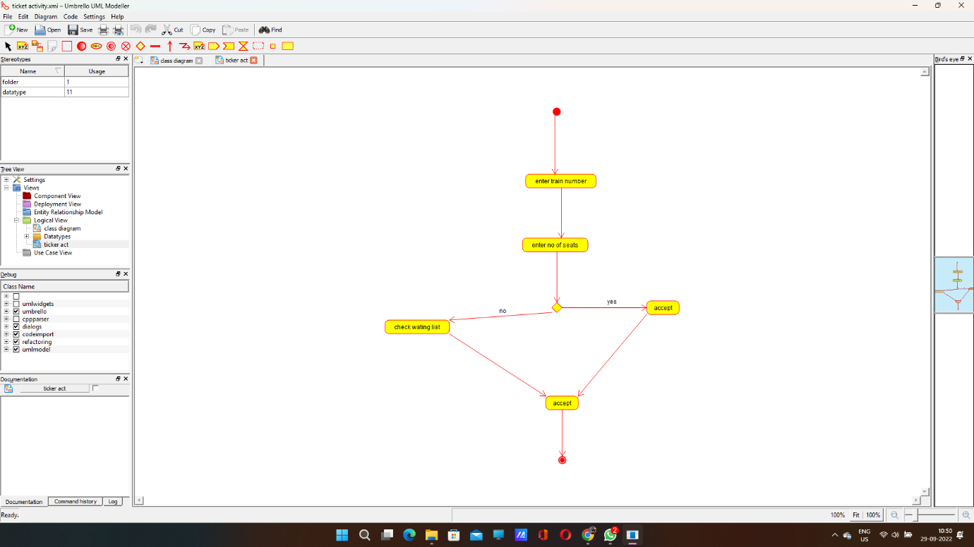

**SEQUENCE DIAGRAM:**

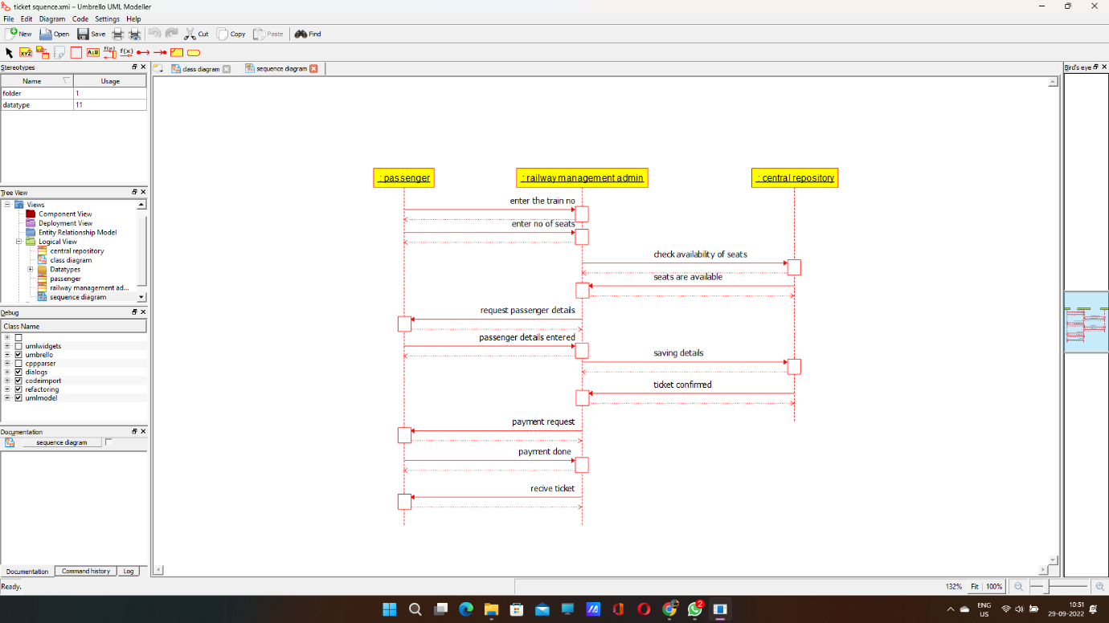

**CALLOBARATION DIAGRAM:** 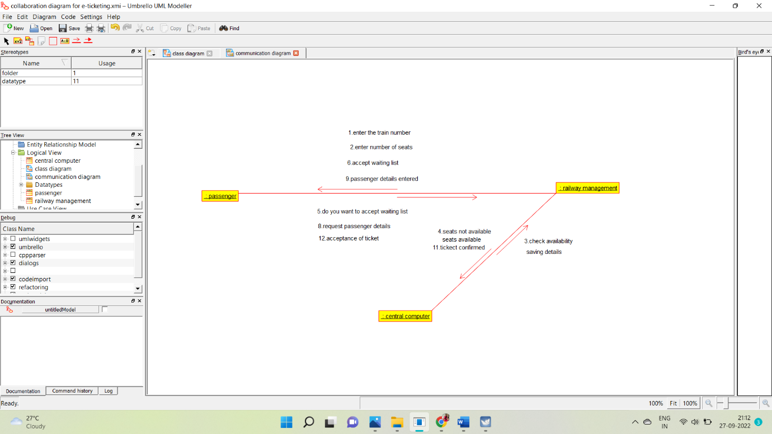

**STATE CHART DIAGRAM**: 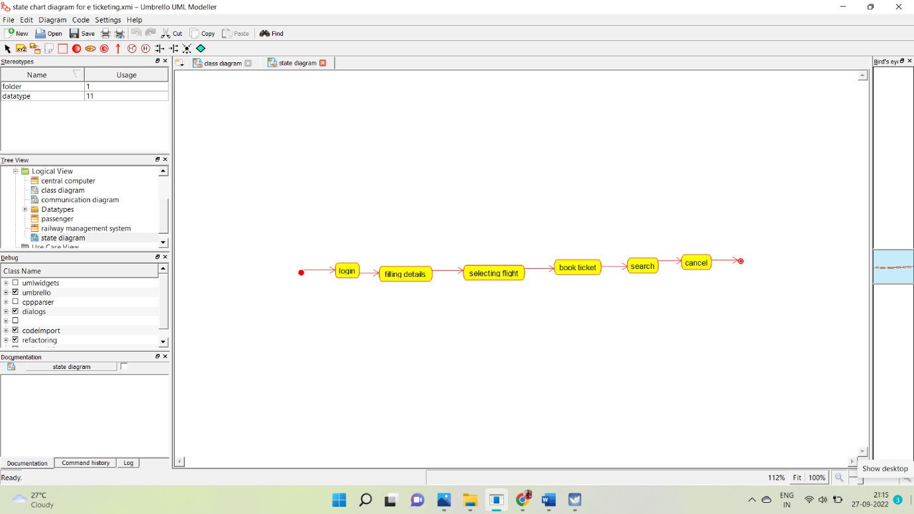

**COMPONENT DIAGRAM:**

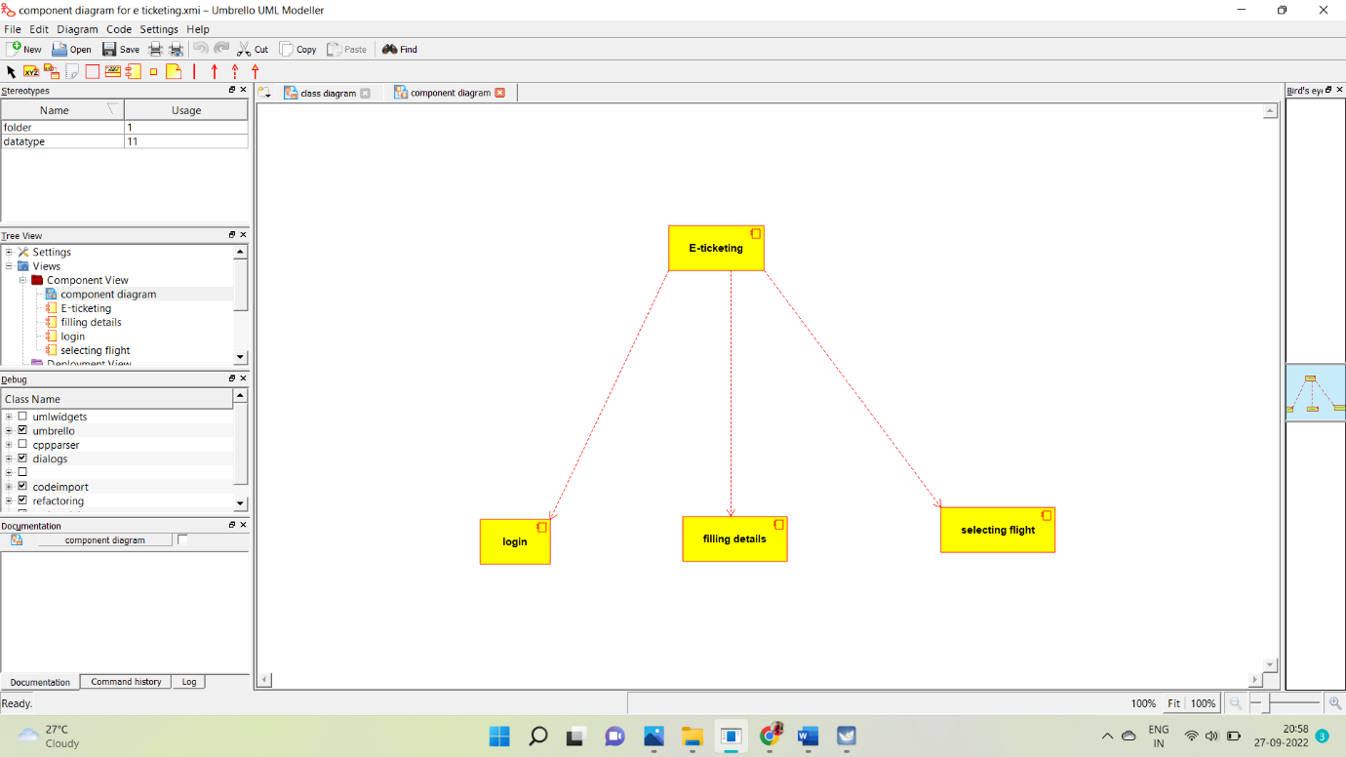

**DEPLOYMENT DIAGRAM:**

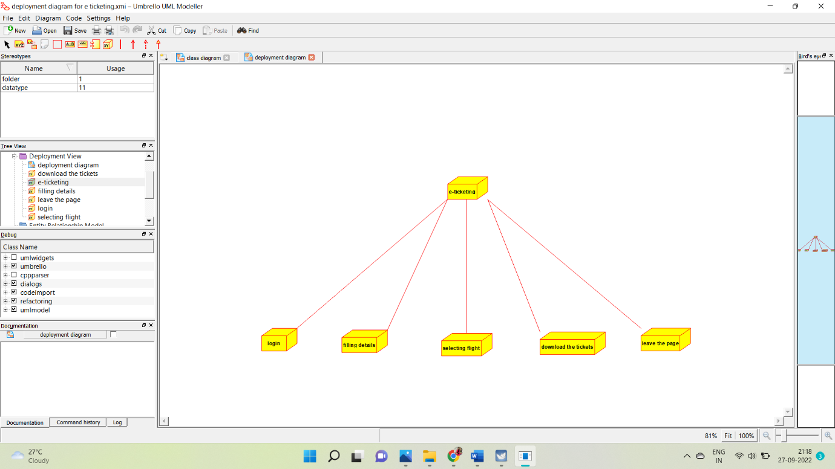

**SKELETON CODE GENERATION:**

/**

* Class admin

*/

public class admin {

//

// Fields

//

//

// Constructors

//

public admin () { };

//

// Methods

//

//

// Accessor methods

//

//

// Other methods

//

}

/**

* Class central_management

*/

public class central_management {

//

// Fields

//

private void train_name;

private void passenger_name;

private void reservation_detaiols;

private void train_details;

//

// Constructors

//

public central_management () { };

//

// Methods

//

//

// Accessor methods

//

/**

* Set the value of train_name

* @param newVar the new value of train_name

*/

private void setTrain_name (void newVar) {

train_name = newVar;

}

/**

* Get the value of train_name

* @return the value of train_name

*/

private void getTrain_name () {

return train_name;

}

/**

* Set the value of passenger_name

* @param newVar the new value of passenger_name

*/

private void setPassenger_name (void newVar) {

passenger_name = newVar;

}

/**

* Get the value of passenger_name

* @return the value of passenger_name

*/

private void getPassenger_name () {

return passenger_name;

}

/**

* Set the value of reservation_detaiols

* @param newVar the new value of reservation_detaiols

*/

private void setReservation_detaiols (void newVar) {

reservation_detaiols = newVar;

}

/**

* Get the value of reservation_detaiols

* @return the value of reservation_detaiols

*/

private void getReservation_detaiols () {

return reservation_detaiols;

}

/**

* Set the value of train_details

* @param newVar the new value of train_details

*/

private void setTrain_details (void newVar) {

train_details = newVar;

}

/**

* Get the value of train_details

* @return the value of train_details

*/

private void getTrain_details () {

return train_details;

}

//

// Other methods

//

/**

*/

public void cancellation_details()

{

}

/**

*/

public void passenger_details()

{

}

}

**8.SOFTWARE MANAGEMENT SYSTEM**

**USECASE DIAGRAM:**

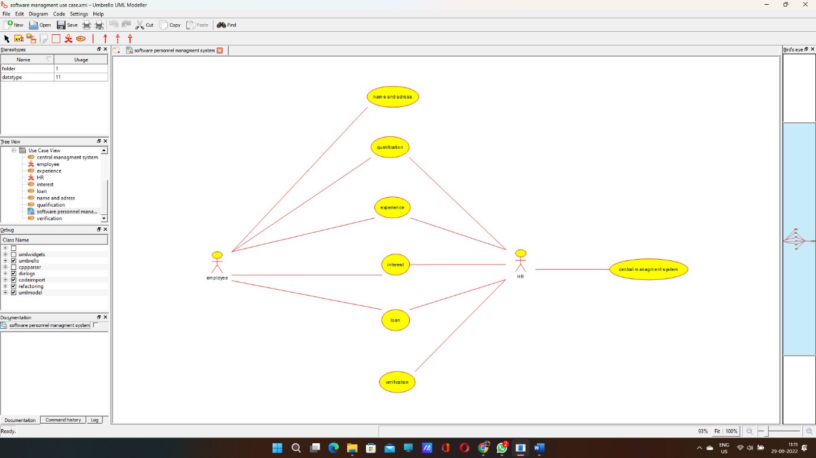

**CLASS DIAGRAM**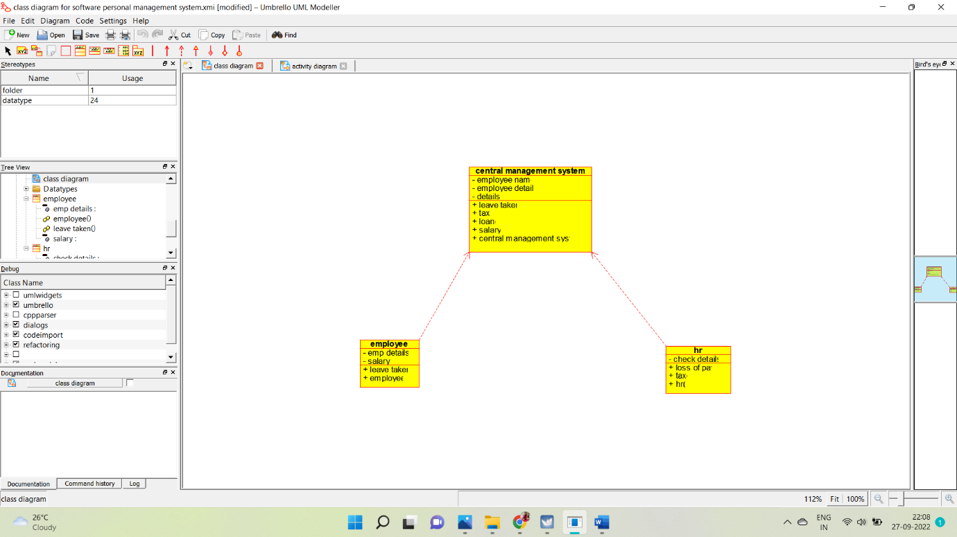

**ACTIVITY DIAGRAM:**

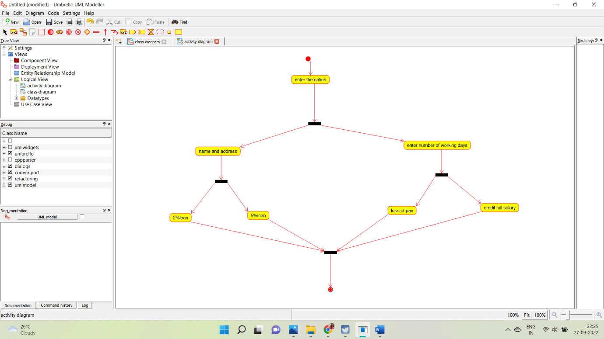

**SEQUENCE DIAGRAM:**

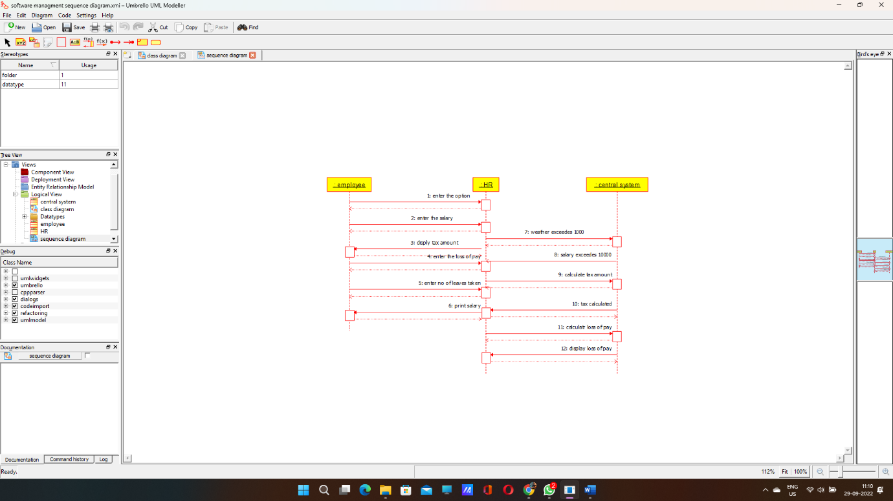

**COLLABORATION DIAGRAM:**

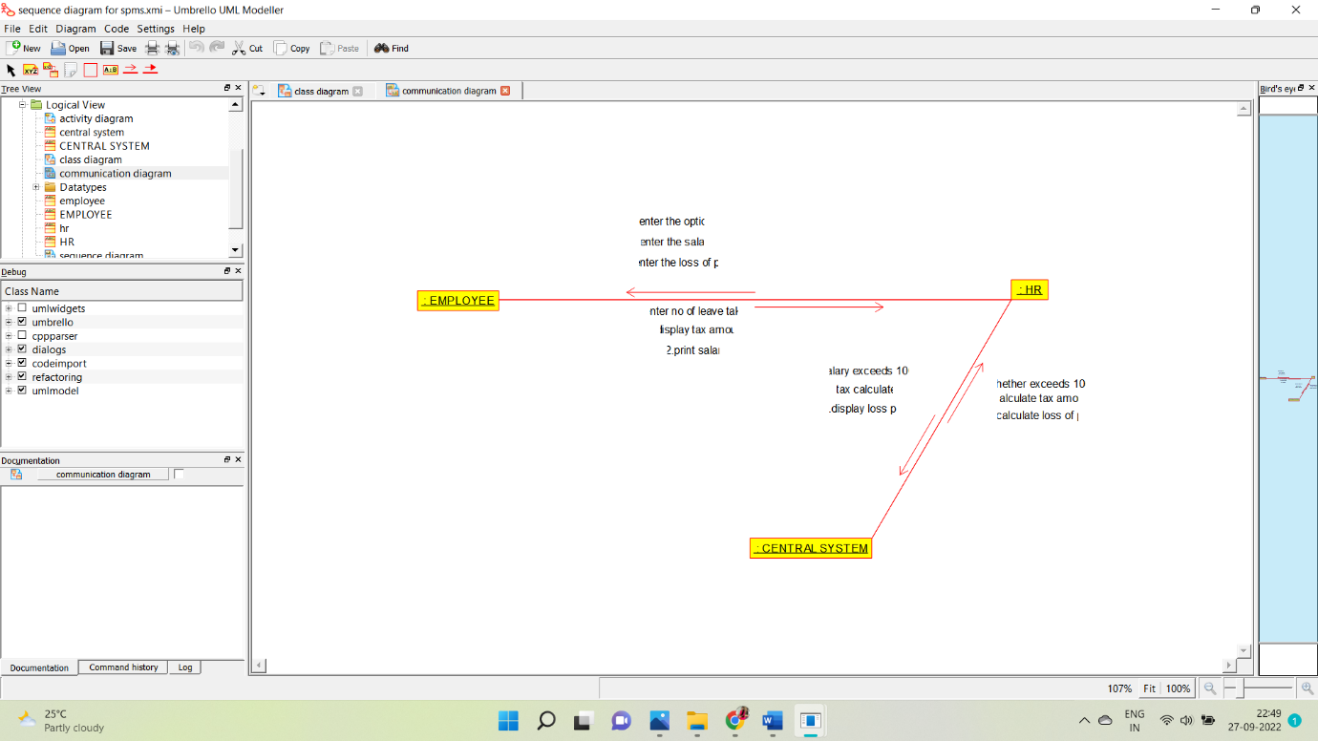

**STATE CHART DIAGRAM:**

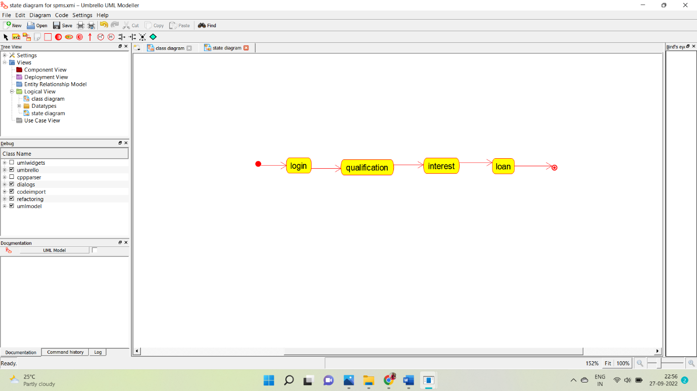

**COMPONENT DIAGRAM:**

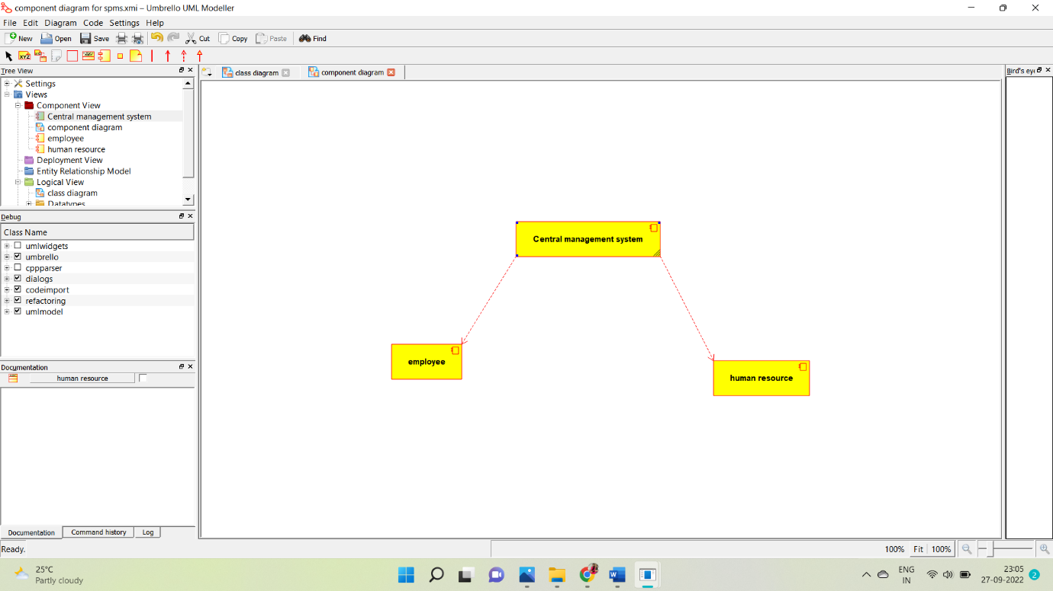

**DEPLOYMENT:**

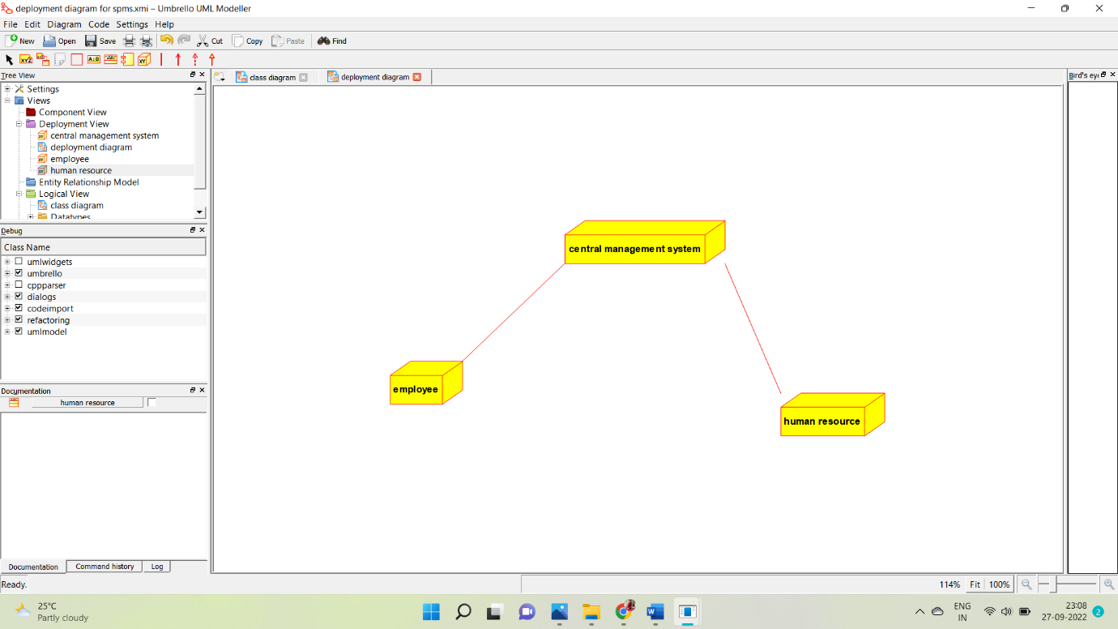

**SKELETON CODE:-**

**EMPLOYEE:**

Public class employee

{

Public integer employee details;

Public integer salary;

Public void leave taken()

{

}

Public void employee()

{

}

}

**HUMAN RESOURCES:**

Public class HR

{

Public integer check details;

Public void loss of pay()

{

}

Public void tax()

{

}

Public void HR()

{

}

}

**CENTRAL MANAGEMENT SYSTEM:**

Public class central management system

{

Public integer employee name;

Public integer employee no;

Public integer details;

Public void leave taken()

{

}

Public void tax()

{

}

Public void loan()

{

}

Public void salary()

{

}

9.E BOOK MANAGEMENT:

USECASE DIAGRAM:

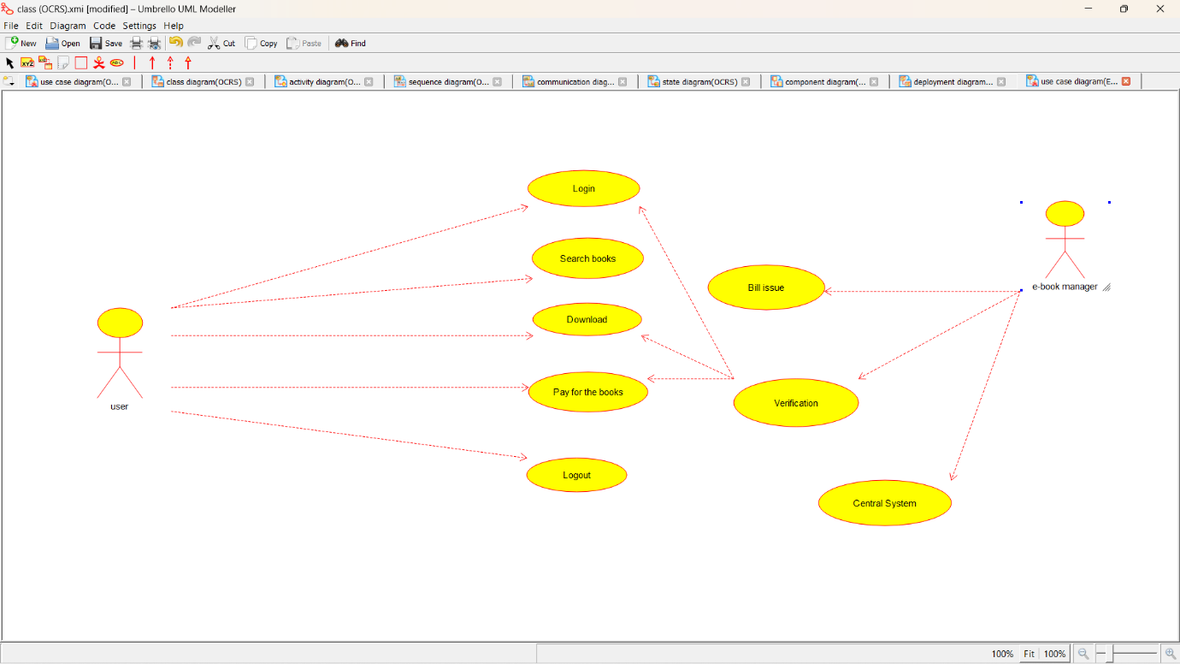

CLASS DIAGRAM:

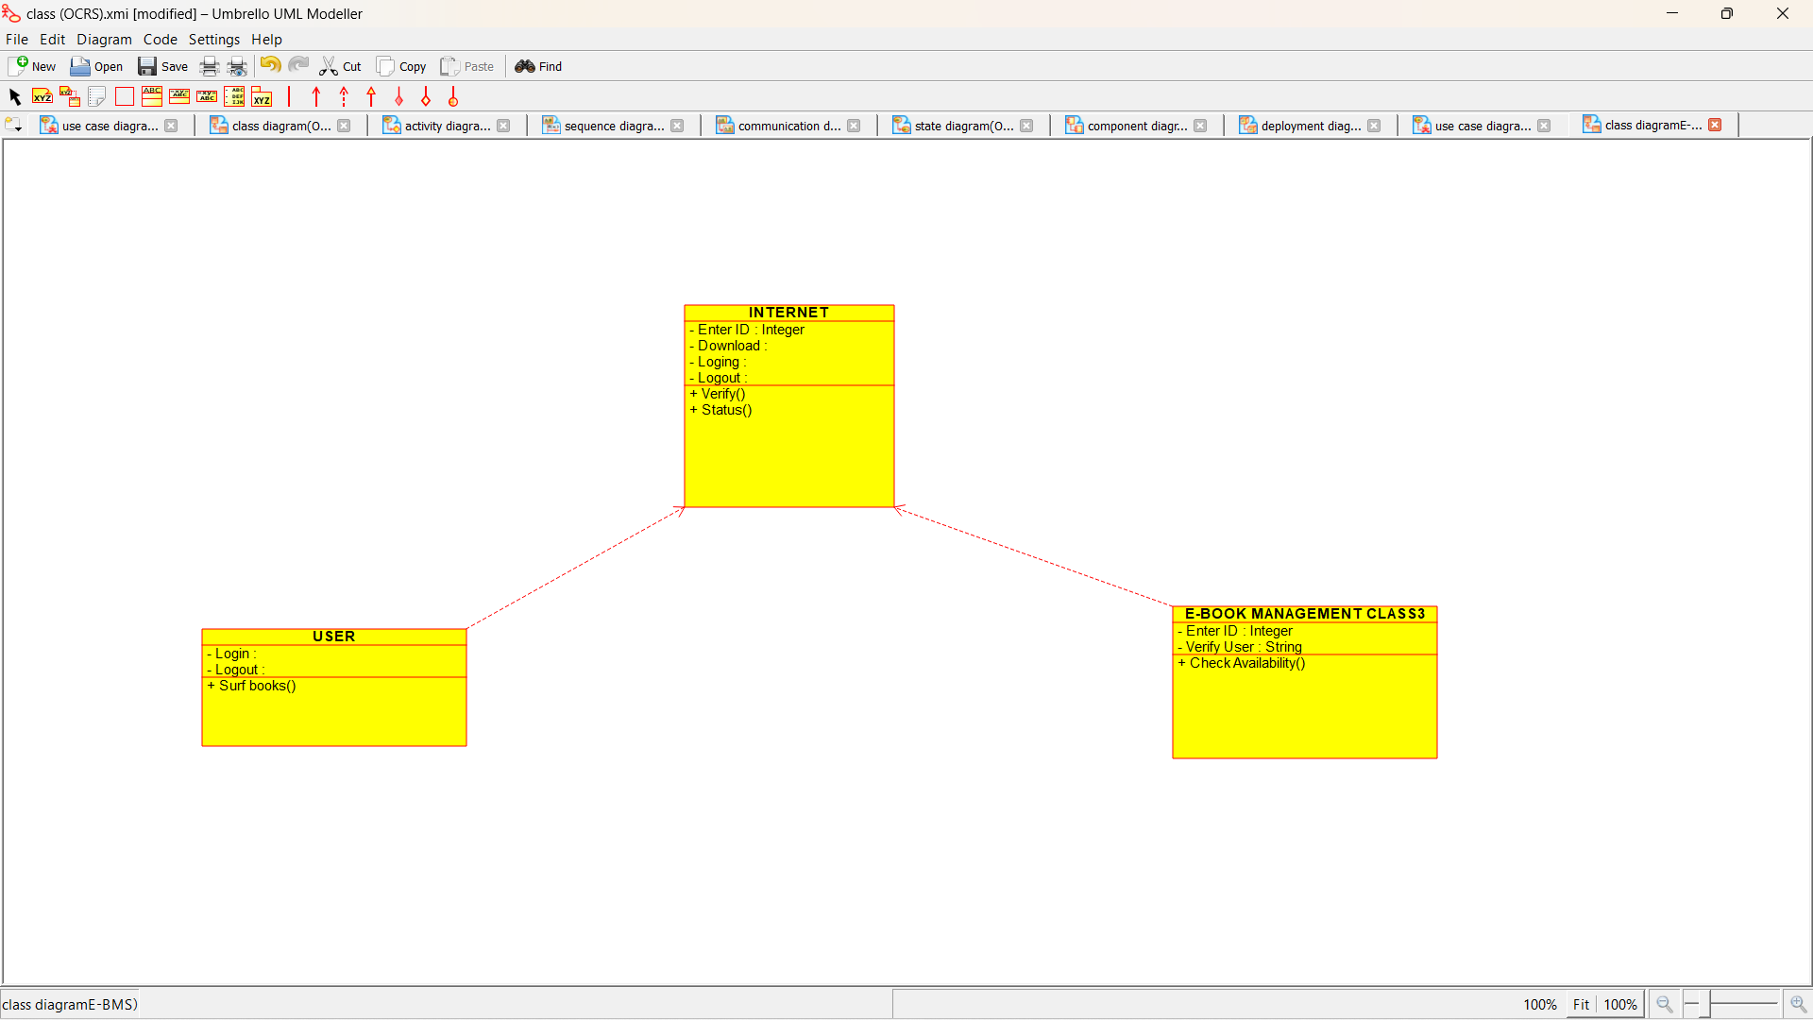

ACTIVITY DIAGRAM:

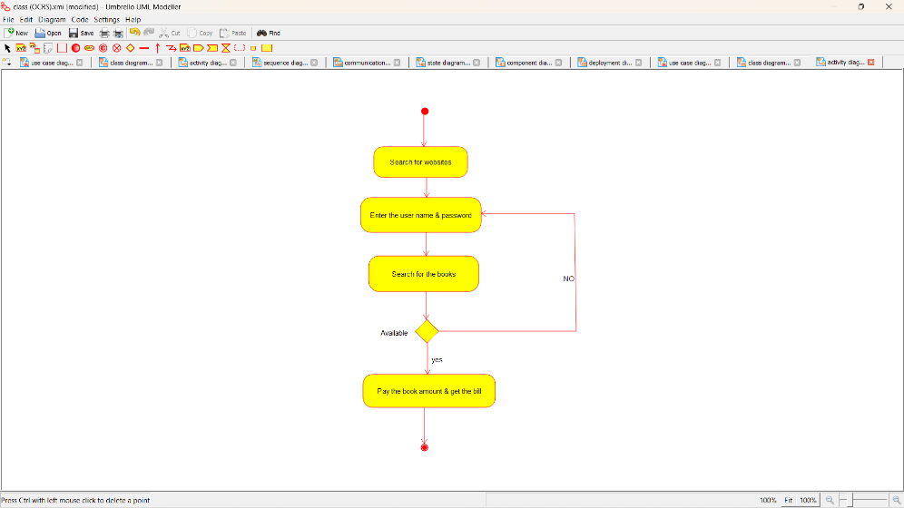

SEQUENCE DIAGRAM:

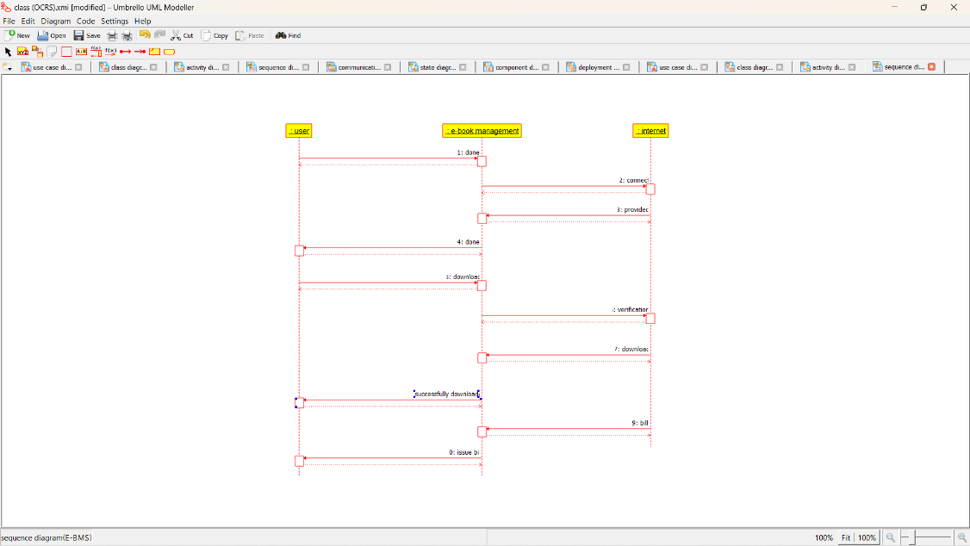

COLLABORATION DIAGRAM: 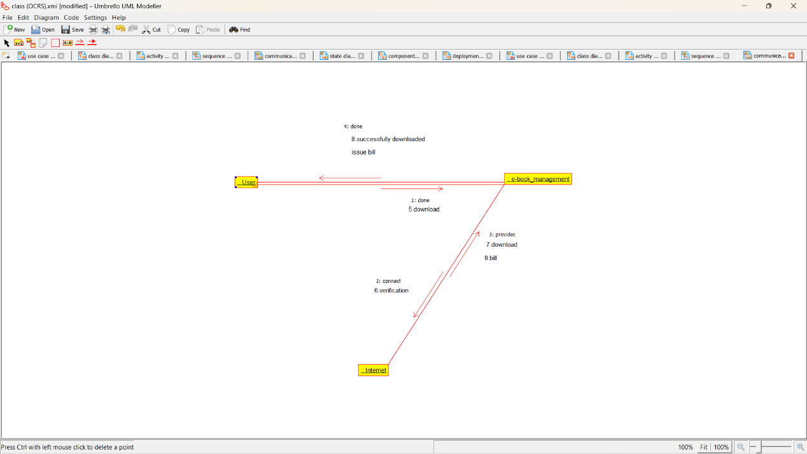

STATE DIAGRAM: 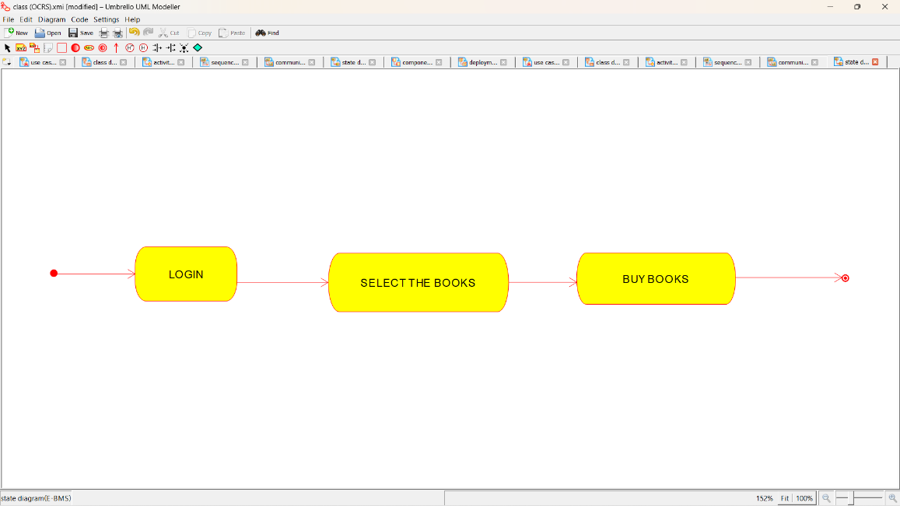

COMPONENT DIAGRAM: 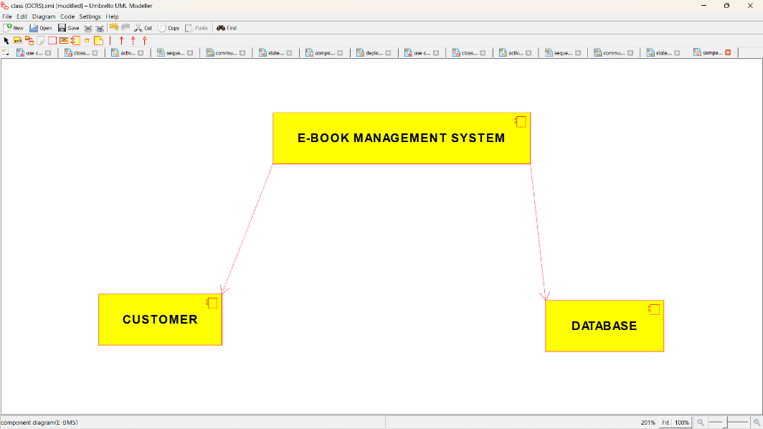

DEPLOYMENT DIAGRAM:

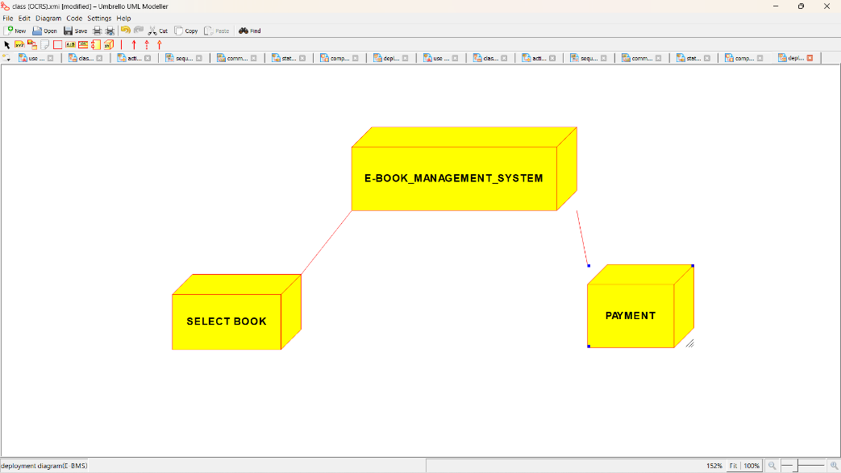

*PROGRAM CODING:*

/**

* Class E_BOOK_MANAGEMENT_CLASS3

*/

public class E_BOOK_MANAGEMENT_CLASS3 {

//

// Fields

//

private Integer Enter_ID;

private String Verify_User;

//

// Constructors

//

public E_BOOK_MANAGEMENT_CLASS3 () { };

//

// Methods

//

//

// Accessor methods

//

/**

* Set the value of Enter_ID

* @param newVar the new value of Enter_ID

*/

private void setEnter_ID (Integer newVar) {

Enter_ID = newVar;

}

/**

* Get the value of Enter_ID

* @return the value of Enter_ID

*/

private Integer getEnter_ID () {

return Enter_ID;

}

/**

* Set the value of Verify_User

* @param newVar the new value of Verify_User

*/

private void setVerify_User (String newVar) {

Verify_User = newVar;

}

/**

* Get the value of Verify_User

* @return the value of Verify_User

*/

private String getVerify_User () {

return Verify_User;

}

//

// Other methods

//

/**

*/

public void Check_Availability()

{

}

}

/**

* Class INTERNET

*/

public class INTERNET {

//

// Fields

//

private Integer Enter_ID;

private void Download;

private void Loging;

private void Logout;

//

// Constructors

//

public INTERNET () { };

//

// Methods

//

//

// Accessor methods

//

/**

* Set the value of Enter_ID

* @param newVar the new value of Enter_ID

*/

private void setEnter_ID (Integer newVar) {

Enter_ID = newVar;

}

/**

* Get the value of Enter_ID

* @return the value of Enter_ID

*/

private Integer getEnter_ID () {

return Enter_ID;

}

/**

* Set the value of Download

* @param newVar the new value of Download

*/

private void setDownload (void newVar) {

Download = newVar;

}

/**

* Get the value of Download

* @return the value of Download

*/

private void getDownload () {

return Download;

}

/**

* Set the value of Loging

* @param newVar the new value of Loging

*/

private void setLoging (void newVar) {

Loging = newVar;

}

/**

* Get the value of Loging

* @return the value of Loging

*/

private void getLoging () {

return Loging;

}

/**

* Set the value of Logout

* @param newVar the new value of Logout

*/

private void setLogout (void newVar) {

Logout = newVar;

}

/**

* Get the value of Logout

* @return the value of Logout

*/

private void getLogout () {

return Logout;

}

//

// Other methods

//

/**

*/

public void Verify()

{

}

/**

*/

public void Status()

{

}

}

/**

* Class USER

*/

public class USER

//

// Fields

//

private void Login;

private void Logout;

//

// Constructors

//

public USER () { };

//

// Methods

//

//

// Accessor methods

//

/**

* Set the value of Login

* @param newVar the new value of Login

*/

private void setLogin (void newVar) {

Login = newVar;

}

/**

* Get the value of Login

* @return the value of Login

*/

private void getLogin () {

return Login;

}

/**

* Set the value of Logout

* @param newVar the new value of Logout

*/

private void setLogout (void newVar) {

Logout = newVar;

}

/**

* Get the value of Logout

* @return the value of Logout

*/

private void getLogout () {

return Logout;

}

//

// Other methods

//

/**

*/

public void Surf_books()

{

}

}

**EX:NO:10 RECRUITMENT SYSTEM**

**USE CASE DIAGRAM:**

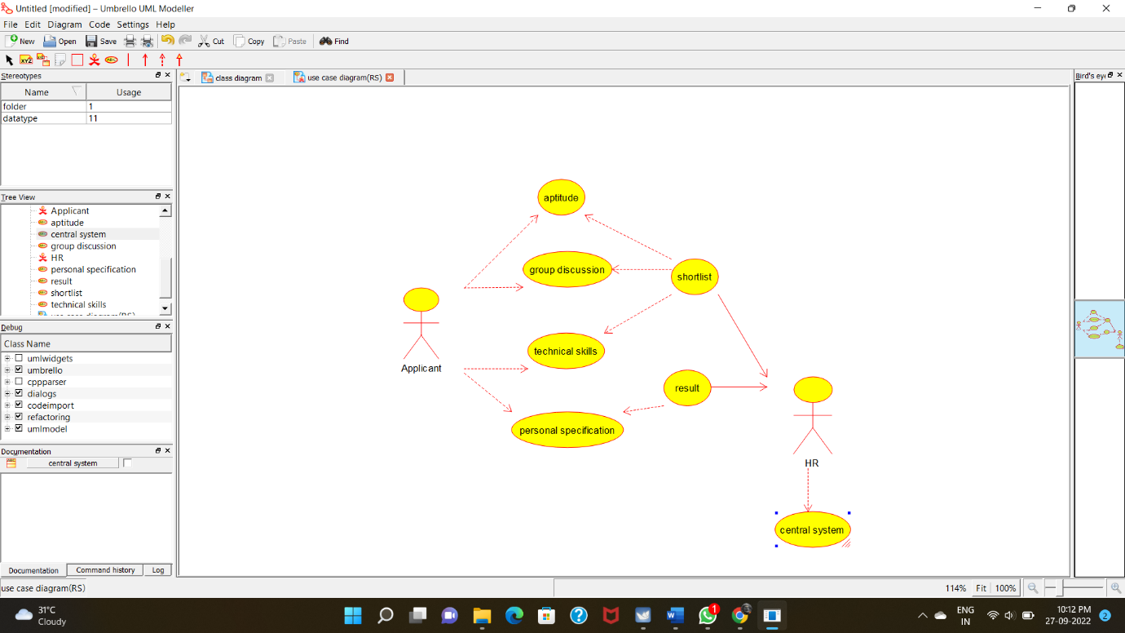

**CLASSDIAGRAM**: 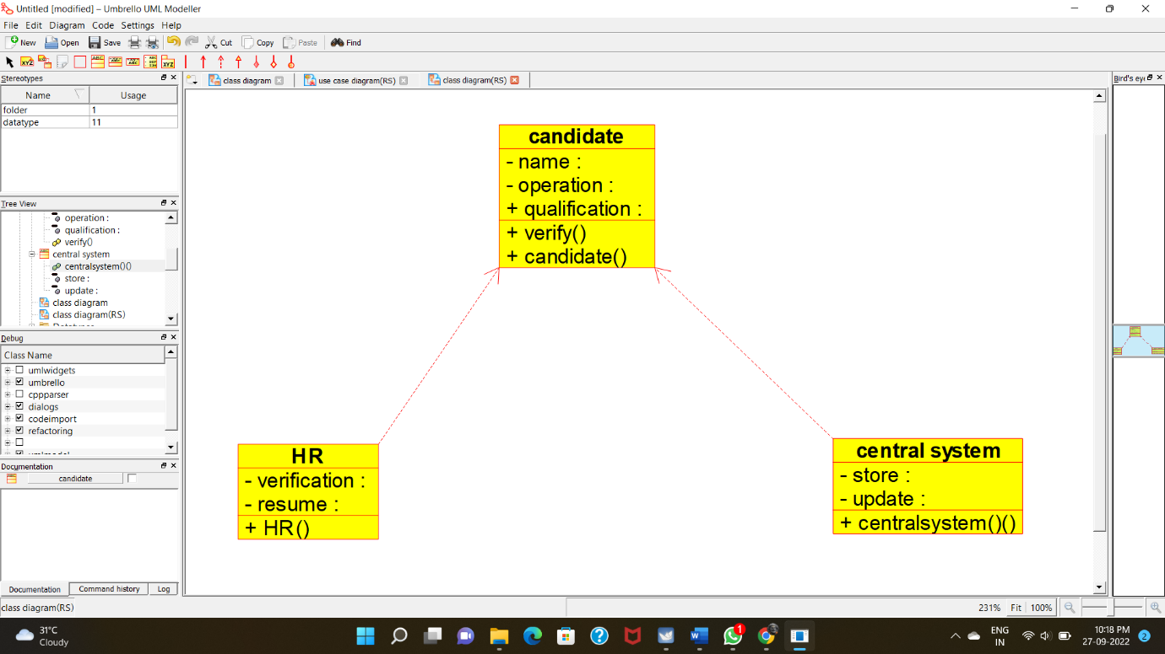

**ACTIVITY DIAGRAM:**

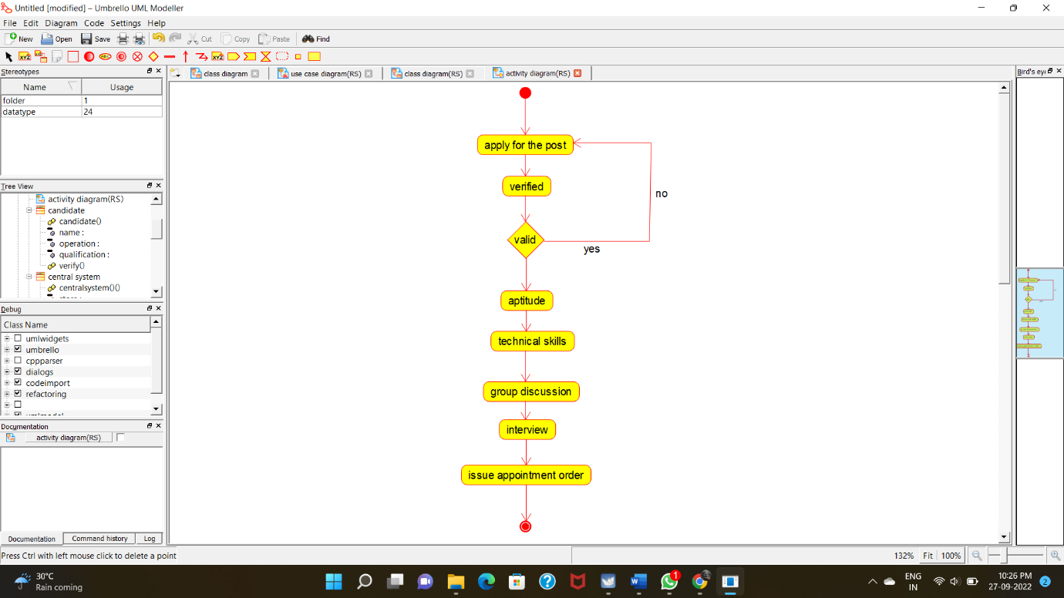

**COLLABORATION DIAGRAM:**

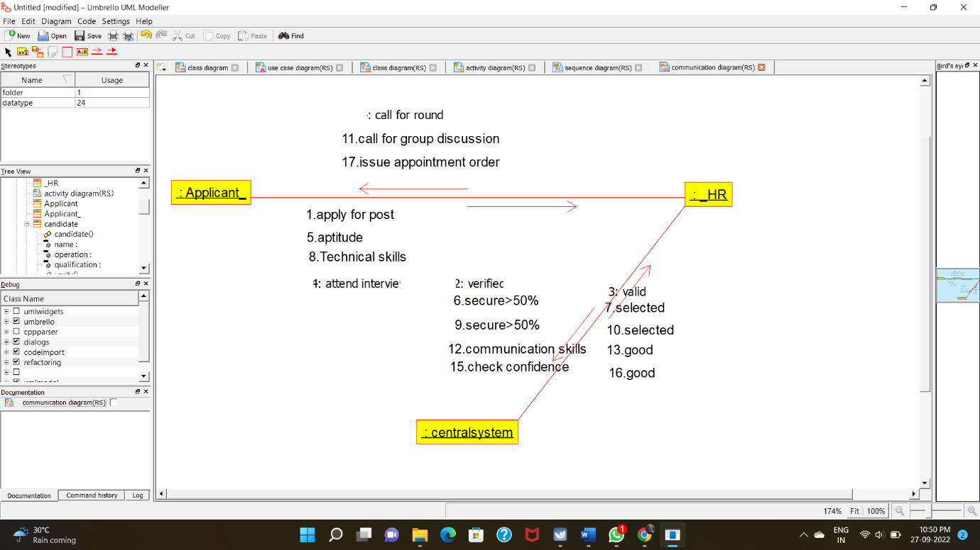

**STATE CHART DIAGRAM:**

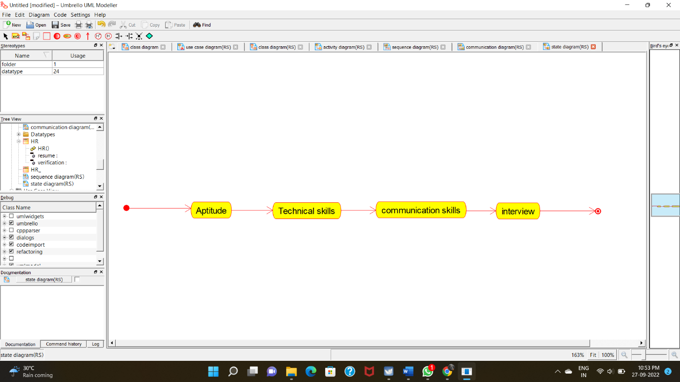

**COMPONENT DIAGRAM:**

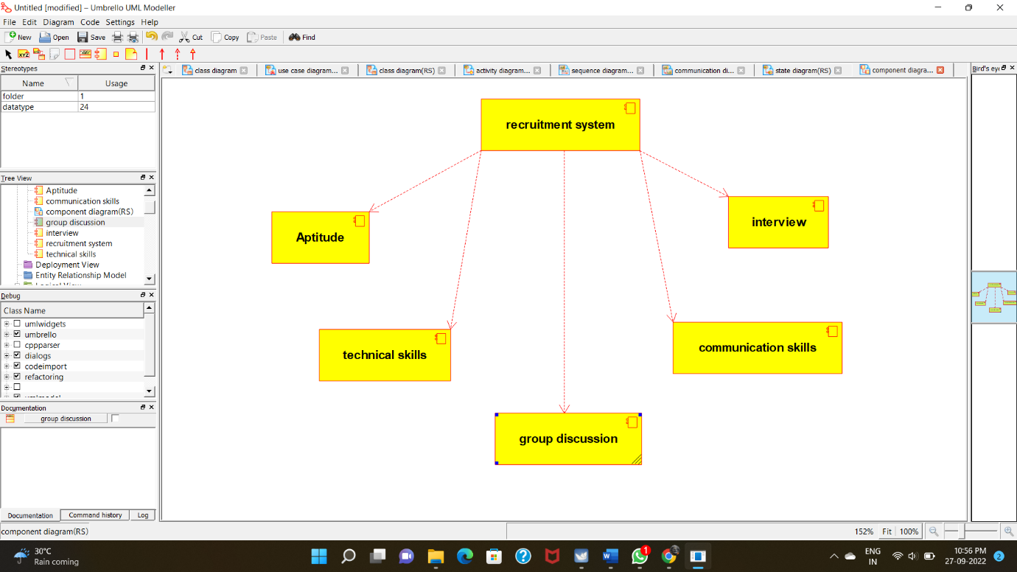

**DEPLOYMENT DIAGRAM:**

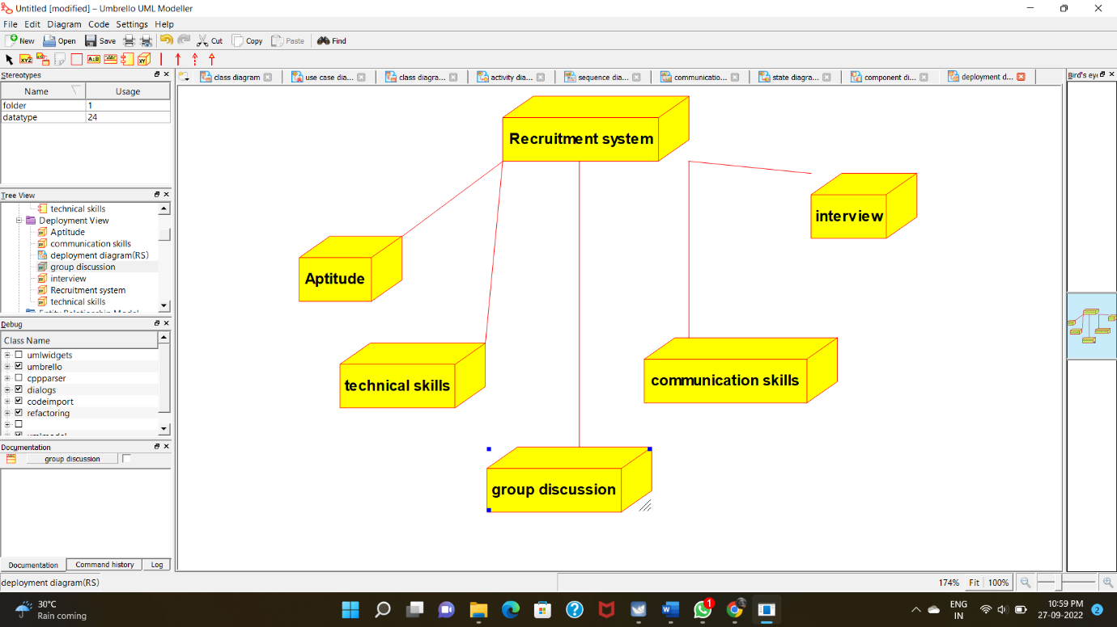

**PROGRAM CODING:**

**CENTRAL SYSTEM:**

**/\*\***

**\* Class central_system**

**\*/**

**public class central_system {**

**//**

**// Fields**

**//**

**private void store;**

**private void update;**

**//**

**// Constructors**

**//**

**public central_system () { };**

**//**

**// Methods**

**//**

**//**

**// Accessor methods**

**//**

**/\*\***

**\* Set the value of store**

**\* @param newVar the new value of store**

**\*/**

**private void setStore (void newVar) {**

**store = newVar;**

**}**

**/\*\***

**\* Get the value of store**

**\* @return the value of store**

**\*/**

**private void getStore () {**

**return store;**

**}**

**/\*\***

**\* Set the value of update**

**\* @param newVar the new value of update**

**\*/**

**private void setUpdate (void newVar) {**

**update = newVar;**

**}**

**/\*\***

**\* Get the value of update**

**\* @return the value of update**

**\*/**

**private void getUpdate () {**

**return update;**

**}**

**//**

**// Other methods**

**//**

**/\*\***

**\*/**

**public void centralsystem_()**

**{**

**}**

**}**

**HR:**

**/\*\***

**\* Class HR**

**\*/**

**public class HR {**

**//**

**// Fields**

**//**

**private void verification;**

**private void resume;**

**//**

**// Constructors**

**//**

**public HR () { };**

**//**

**// Methods**

**//**

**//**

**// Accessor methods**

**//**

**/\*\***

**\* Set the value of verification**

**\* @param newVar the new value of verification**

**\*/**

**private void setVerification (void newVar) {**

**verification = newVar;**

**}**

**/\*\***

**\* Get the value of verification**

**\* @return the value of verification**

**\*/**

**private void getVerification () {**

**return verification;**

**}**

**/\*\***

**\* Set the value of resume**

**\* @param newVar the new value of resume**

**\*/**

**private void setResume (void newVar) {**

**resume = newVar;**

**}**

**/\*\***

**\* Get the value of resume**

**\* @return the value of resume**

**\*/**

**private void getResume () {**

**return resume;**

**}**

**//**

**// Other methods**

**//**

**/\*\***

**\*/**

**public void HR()**

**{**

**}**

**}**

**CANDIDATE:**

**/\*\***

**\* Class candidate**

**\*/**

**public class candidate {**

**//**

**// Fields**

**//**

**public void qualification;**

**private void name;**

**private void operation;**

**//**

**// Constructors**

**//**

**public candidate () { };**

**//**

**// Methods**

**//**

**//**

**// Accessor methods**

**//**

**/\*\***

**\* Set the value of qualification**

**\* @param newVar the new value of qualification**

**\*/**

**public void setQualification (void newVar) {**

**qualification = newVar;**

**}**

**/\*\***

**\* Get the value of qualification**

**\* @return the value of qualification**

**\*/**

**public void getQualification () {**

**return qualification;**

**}**

**/\*\***

**\* Set the value of name**

**\* @param newVar the new value of name**

**\*/**

**private void setName (void newVar) {**

**name = newVar;**

**}**

**/\*\***

**\* Get the value of name**

**\* @return the value of name**

**\*/**

**private void getName () {**

**return name;**

**}**

**/\*\***

**\* Set the value of operation**

**\* @param newVar the new value of operation**

**\*/**

**private void setOperation (void newVar) {**

**operation = newVar;**

**}**

**/\*\***

**\* Get the value of operation**

**\* @return the value of operation**

**\*/**

**private void getOperation () {**

**return operation;**

**}**

**//**

**// Other methods**

**//**

**/\*\***

**\*/**

**public void verify()**

**{**

**}**

**/\*\***

**\*/**

**public void candidate()**

**{**

**}**

**}**